Date: July 2025

Independent Learning and Evaluation of the Effectiveness of the UK’s Support to Climate Vulnerable Country Negotiating Groups in International Climate Negotiations
Final Evaluation of the CASA II programme 2023–25:
Case Studies
DESNZ

Contents
1. Case study 1: Least Developed Countries (LDC) Group 7
1.1 Summary of CASA II contribution 7
1.2 Summary of the contribution of other actors and factors 7
1.3 Geographic and temporal context 8
1.4 What did the LDC Group do? 9
1.5 Intermediate outcomes – What changed? 11
1.6 How effective were TPs in this period? 15
1.7 What were other advocates/actors doing during the same period? 17
1.8 What were the key factors in determining the outcome? 18
2. Case study 2: Legal Response Initiative 22
2.1 Summary of CASA II contribution 22
2.2 Summary of the contribution of other actors and factors 22
2.3 Geographic and temporal context 22
2.4 What did LRI do? 23
2.5 Intermediate outcomes – What changed? 24
2.6 How effective were the TPs during the period? 26
2.7 What were other advocates/actors doing during the same period? 26
2.8 What were the key factors in determining the outcome? 27
3. Case study 3: New Generation Programme 30
3.1 Summary of CASA II contribution 30
3.2 Summary of the contribution of other actors and factors 30
3.3 Geographic and temporal context 31
3.4 What did NGP do? 31
3.5 Intermediate outcomes – What changed? 32
3.6 How effective was the implementation of NGP? 33
3.7 What were other advocates/actors doing during the same period? 34
3.8 What were the key factors in determining the outcome? 34
4. Case study 4: Republic of the Marshall Islands and the High Ambition Coalition 38
4.1 Summary of CASA II contribution 38
4.2 Summary of the contribution of other actors and factors 38
4.3 Geographic and temporal context 38
4.4 What did Independent Diplomat do? 40
4.5 Intermediate outcomes – What changed? 41
4.6 How effective were the TPs during the period? 42
4.7 What were other advocates/actors doing during the same period? 42
4.8 What were the key factors in determining the outcome? 43
5. Case study 5: Independent Alliance of Latin America and the Caribbean 46
5.1 Summary of CASA II contribution 46
5.2 Summary of the contribution of other actors and factors 46
5.3 Geographic and temporal context 46
5.4 What did the TP do? 47
5.5 Intermediate outcomes – What changed? 48
5.6 How effective were the TPs during the period? 49
5.7 What were other advocates/actors doing during the same period? 49
5.8 What were the key factors in determining the outcome? 49
6. Case study 6: Mountainous Ranges and Nepal 51
6.1 Summary of CASA II contribution 51
6.2 Summary of the contribution of other actors and factors 51
6.3 Geographic and temporal context 51
6.4 What did the OF grantees do? 52
6.5 Intermediate outcomes – What changed? 54
6.6 How effective were the TPs during the period? 55
6.7 What were other advocates/actors doing during the same period? 56
6.8 What were the key factors in determining the outcome? 57

Acronyms
Acronym | Definition
AOSIS | Alliance of Small Island States
AILAC | Independent Association of Latin America and the Caribbean
CaBIN | Capacity Building for International Negotiations
CASA | Climate Ambition Support Alliance
CASA II | Climate Ambition Support Alliance Phase II
CDKN | Climate Development Knowledge Network
CIES | Consorcio de Investigación Económica y Social (Economic and Social Research Consortium)
CLI | Climate Leadership Initiative
COP | Conference of the Parties
CYNP | Climate Youth Negotiator Programme
DAC | Development Assistance Committee
DESNZ | Department for Energy Security and Net Zero
EQ | Evaluation Question
FCDO | UK Foreign, Commonwealth and Development Office
GEF | Global Environment Facility
GESI | Gender Equality and Social Inclusion
HAC | High Ambition Coalition
ICCCAD | International Centre for Climate Change and Development
ICF | International Climate Finance
IIED | International Institute for Environment and Development
IPCC | Intergovernmental Panel on Climate Change
KII | Key Informant Interview
KPI | Key Performance Indicator
LAPA | Local Adaptation Plan of Action
LDC | Least Developed Country
LEP | Learning and Evaluation Partner
LRI | Legal Response International
M&E | Monitoring and Evaluation
MEL | Monitoring, Evaluation and Learning
NCQG | New Collective Quantified Goal
NDCs | Nationally Determined Contributions
NGP | New Generation Programme
ODI | Overseas Development Institute
OECD | Organisation for Economic Co-operation and Development
OF | Opportunity Fund
OPM | Oxford Policy Management
RMI | Republic of the Marshall Islands
SB | Subsidiary Body
SIDS | SIDS
TP | Technical Partner
UK | United Kingdom
UNFCCC | United Nations Framework Convention on Climate Change
UNIDO | United Nations Industrial Development Organization
VFM | VFM – Value for Money
YNA | Youth Negotiators Academy

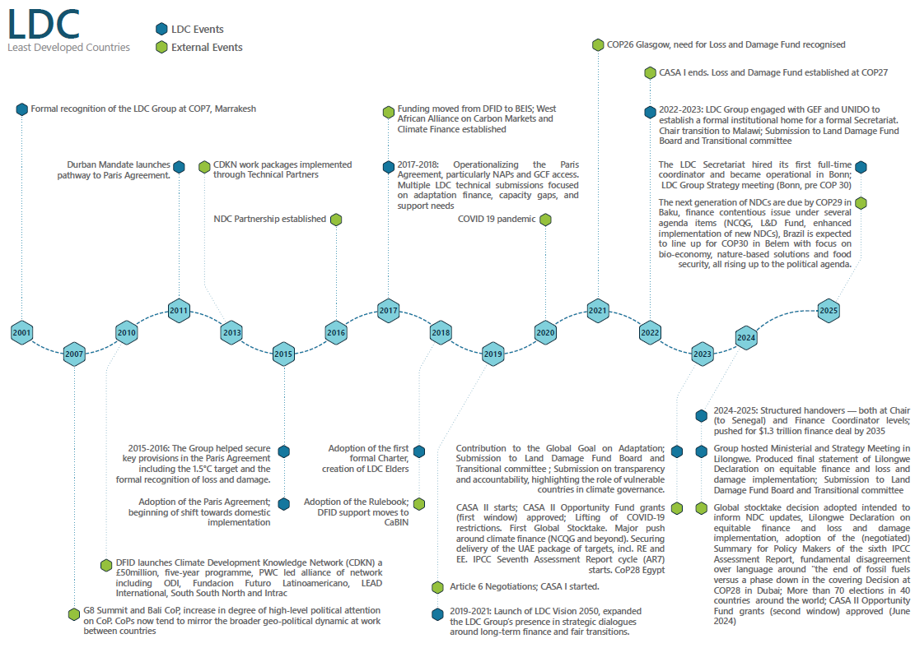
Figure 1. Timeline for the LDC Group case study

Case study 1: Least Developed Countries (LDC) Group
Outcome title:  Institutionalisation of the LDC Group’s internal functions and external engagement | Strength of evidence  Strong

Summary of CASA II contribution
Very confident that CASA II made a critical contribution.
Over the last decade, the LDC Group has developed into a more formalised, permanent institution that attracts and nurtures climate leaders from the Global South and has been able to solidify its position within the negotiation space. It would be inconceivable that the LDC Group were not participating in global negotiations across all thematic areas, and a precedent for Intergovernmental Panel on Climate Change (IPCC) submissions by the group has now been set. The group has formalised the infrastructure to take its work into the next decade, with a degree of institutional memory ensuring the group’s established processes remain. The International Institute for Environment and Development (IIED), Climate Analytics and Germanwatch were instrumental in their support to the LDC Group to sustain visibility, coherence, and influence across this period. Without CASA’s sustained, flexible support, many of the internal systems and negotiation-ready processes would not have matured.
The CASA II programme and its predecessors have been a critical enabler of institutional strengthening within the LDC Group. Through its funding, technical partners (TPs)—primarily Climate Analytics and IIED—have formed the operational backbone of the LDC Group’s negotiation architecture. CASA supported the Group’s ability to coordinate, prepare, and engage consistently throughout the United Nations Framework Convention on Climate Change (UNFCCC) calendar. Importantly, CASA’s model allowed funding to flow directly to implementation of workplans co-created with the chair’s team. It enabled the Group to function year-round (i.e. not only during Conferences of the Parties (COPs)) and supported the emergence of institutional practices such as weekly strategy calls, internal submission reviews, and multilingual WhatsApp coordination groups. Furthermore, Climate Analytics provided in-country support to chairs and led regular technical coordination calls, briefing sessions, and draft text preparation. IIED played a complementary role supporting the development of a coherent external engagement strategy, negotiation coaching, and providing expert input into themes including Loss and Damage and adaptation. Further, TPs contributed to the development and adoption of the LDC Charter, enabling transparent chair selection and internal governance.

Summary of the contribution of other actors and factors
- Leadership by chairs and in-country support teams | Critical contribution
- National incentives and rising value of the chairship | Critical contribution
- Alumni continuity and internal expertise | Critical contribution
- Expanding youth pipeline and fellowships | Important contribution
- Structural participation barriers | Important contribution
- Resourcing barriers acting as a constraint to LDC negotiators | Important contribution
- United Nations Industrial Development Organization (UNIDO)-led Secretariat formation | Some contribution
- Evolving relationships with other negotiating blocs | Some contribution
- TP capacity supported by other funders | Insufficient evidence

Geographic and temporal context
The decade following the adoption of the Paris Agreement in 2015 has seen a dynamic reshaping of the global climate negotiations landscape. The field has evolved from securing international consensus on goals to grappling with the political, financial, and technical realities of implementation. This period has tested the durability of the multilateral system and has demanded increasing sophistication and agility from negotiating blocs like the LDC Group.
The period from 2023 to 2025 was marked by intense and overlapping negotiation cycles, including COP28, COP29, the Global Stocktake conclusion, and operationalisation of the Loss and Damage Fund. IIED, Climate Analytics, and Germanwatch were instrumental in helping the LDC Group sustain visibility, coherence, and influence across this period.
The LDC Group currently has 44 members. The list of members and other information on the negotiating group can be found on the LDC Group website. Membership of the group is defined based on standards agreed by the UN Economic and Social Council. Every three years, the list of countries included in the list is revised, based on the threshold criteria, country-specific information compiled by the UN, and the views of the government. Once it has been established that a country no longer fulfils the criteria for an LDC country, it ‘graduates’.
Many decisions in the UNFCCC state that LDCs and Small Island Developing States (SIDS) are not obliged to do certain things but rather are merely encouraged to. According to UNCTAD, Bangladesh, Lao PDR, and Nepal are scheduled to graduate from the group in 2026. Solomon Islands is scheduled to graduate in 2027, and Cambodia and Senegal are scheduled to graduate in 2029. By 2030, the LDC Group will have only 38 members.
The Charter which governs the group was formalised under the Bhutan chair and is available on the LDC Group website.
Shifting power dynamics
One of the most significant developments has been the reassertion of major emerging economies and fossil fuel producers in slowing or softening ambition. Saudi Arabia has played a consistent role in limiting progress on topics such as a fossil fuel phase-out and the transparency framework, often acting in coordination with other oil-producing nations. Meanwhile, BRICS countries (particularly China, Saudia Arabia, and India) have adopted a dual posture: defending equity principles and historical responsibility, while resisting prescriptive obligations on mitigation and finance transparency.
The US rejoined the Paris Agreement under the Biden administration in 2021, after a period of withdrawal during the first term of President Trump. While the return of the US to the negotiating table was welcomed, its negotiation strategy remained cautious, especially on Loss and Damage, out of concern over potential liability. The US supported climate finance mobilisation but prioritised voluntary pledges and market mechanisms over the grant-based approaches preferred by LDCs. In 2025, the US again stepped back from the global climate policy stage, indicating that it does not back a movement towards net zero.
In this context, the European Union (EU) has emerged as a consistent ally to the LDCs on adaptation and finance, although internal fragmentation—particularly between progressive and conservative member states—has limited the EU’s ability to lead on transformative reforms.
Global South visibility
Over the past decade, Global South negotiation blocs under the G77+China umbrella—including the LDC Group, African Group of Negotiators (AGN), the Alliance of Small Island States (AOSIS), and the Like-Minded Developing Countries—have deepened their coordination and improved policy coherence. The LDC Group has increasingly aligned with AGN and AOSIS on key agenda items such as the Global Goal on Adaptation (GGA), Loss and Damage, and grant-based finance.
Bloc collaboration was particularly visible during:
- COP27 (2022), when joint pressure led to the agreement on the Loss and Damage Fund;
- The Global Stocktake (2023–24), where developing countries demanded stronger references to common but differentiated responsibilities; and,
- The UAE Framework for Global Climate Resilience, where LDCs successfully secured equity-based adaptation indicators.

Youth and non-state actors
A key shift in the climate space this last decade (mostly since 2019) has been the rise of youth and civil society mobilisation, particularly from the Global South. Youth activists have increased their presence both inside negotiating halls and through parallel forums. These groups have applied pressure for bolder action on inter-generational equity, climate finance, and inclusivity—issues the LDC Group has increasingly sought to integrate into its own messaging.
Initiatives such as the Youth Negotiators Academy, IIED Fellowship Programme, AGNES negotiator training, and youth engagement via the Climate Leadership Initiative’s (CLI) New Generation Programme (NGP) (importantly, all of which have been supported by CASA) have helped increase the pipeline of capable negotiators from LDC countries. These developments have also improved the Group’s internal diversity, including stronger participation from women and Francophone delegates.

What did the LDC Group do?
Over the last decade—and particularly under the CASA programme—IIED, Climate Analytics, and Germanwatch have provided complementary and evolving support to the LDC Group across negotiation strategy, policy development, coordination mechanisms, and institutional strengthening. Their roles are shaped by a Memorandum of Understanding (MoU) between the three TPs and the LDC Chair and support has been demand-led, with TPs responding directly to requests from the chair and group coordinators.
IIED has operated as the main policy and strategy advisor to the LDC Chair. Its work spans:
- Negotiation support: real-time legal, technical, and strategic advice across agenda items (e.g. Loss and Damage, transparency, just transition, and adaptation).
- Chair’s office support: embedding two full-time consultants in Malawi—an Executive Officer and a Media & Diplomacy Coordinator—to directly manage the chair’s calendar, media strategy, and logistical coordination.
- Media and advocacy: managing the chair’s social media, preparing talking points, supporting press events, and promoting LDC visibility (e.g. during COP29 and the United Nations General Assembly (UNGA)).
- Organisational support: leading the development of the LDC knowledge platform and uploading foundational documents to preserve institutional memory, in preparation for the Secretariat transition.
- Submissions drafting: advising on and drafting formal submissions on issues such as the GGA and transparency indicators.
- Capacity building: implementing the IIED Fellowship and mentoring programme for junior, women, and Francophone negotiators. Between 2023 and 2025, CASA funding enabled eight junior negotiators to attend Bonn and included mentoring.

Climate Analytics has been the primary technical and scientific adviser, offering strategic and real-time support on both thematic and procedural issues. Its contributions include:
- Scientific analysis: Providing evidence to underpin LDC positions in negotiations, particularly on mitigation (Global Stocktake), just transition, and adaptation.
- Loss and Damage: Supporting LDC efforts in the design of the Loss and Damage Fund and coordinating inputs for Board members and thematic coordinators.
- Chair coordination: Collaborating with both the LDC and AOSIS Chairs, crafting strategy documents.
- Offering political and thematic coaching to coordinators and youth fellows.
- Support to the adaptation track: A member of Climate Analytics worked as a counterpart to LDC adaptation leads, providing daily inputs during negotiations.
- Media and visibility: Climate Analytics supported strategic media moments, including the joint LDC/AOSIS press conference at UNGA and New York Climate Week in the latter part of 2024.
- IPCC engagement: Supported LDC contributions to the IPCC processes and (negotiation of) the Summary for Policy Makers of the Sixth Assessment Report.

Germanwatch’s work has primarily focused on climate finance, notably in relation to the Green Climate Fund (GCF) and the New Collective Quantified Goal (NCQG). Their contributions include:
- Board-level support: Advised LDC representatives on GCF Board proceedings, including guidance to Bhutan and Liberia’s representatives, followed by The Gambia. This helped smooth the transition from yearly to three-year terms to ensure institutional continuity.
- Policy engagement: Supported the development of NCQG negotiating positions, long-term finance dialogues, and GCF guidance submissions.
- Indirect coordination: Interaction with the LDC Group often occurred through Board members rather than through the Chair, which allowed for specialised policy engagement. This, however, limited the wider institutional influence of the support.

Importantly, not all of Climate Analytics’ work with the LDC Group is funded by CASA and the organisation has reportedly been able to leverage its considerable experience and reach from other projects. While this offers a level of value for money, and reflects CASA’s strategic investment in a TP’s stock of assets, this presents challenges in attributing Climate Analytics-supported LDC Group outcomes to CASA.

Intermediate outcomes – What changed?
1. Capacity and organisational strengthening
The LDC Group’s negotiating capacity has significantly evolved during the CASA II period, with notable progress in both individual skills and institutional systems. These gains have been driven by targeted investments in mentoring, gender and youth inclusion, governance structures, and strategic communications—all supported consistently by CASA-funded TPs, notably IIED and Climate Analytics.
Individual capacity: Mentoring, thematic depth, and leadership transitions
One of the clearest areas of progress has been in cultivating a technically confident, more diverse cohort of LDC negotiators. The IIED Fellowship Programme played a foundational role in this shift. Between 2022 and 2024, it supported over a dozen junior negotiators across key agenda tracks such as transparency, Article 6, finance, and just transition.
Several fellows now occupy central roles within the LDC Group and national delegations:
- Brenda Mwale (Malawi) now supports the LDC chair in her capacity as Climate Diplomacy Advisor for Climate Analytics. Another alumna of the first cohort;
- Olivier Ishimwe (Rwanda) is co-coordinating Article 6 for the LDC Group and was recently selected to be LDC alternate member to the Article 6.4 Mechanism Supervisory Body.
- Prakriti Koirala (Nepal) works together with the Government of Nepal in building national position papers for COPs and is also involved in drafting key national documents like NDC 3. 0.. She is also a core team member of New Generation Program, a youth negotiator support programme also now supported by CASA.
Among other fellows, there is strong evidence that the Fellowship played a critical role in enhancing their understanding of the UNFCCC process.
Institutional systems: Charter, Elders, and knowledge practices
CASA II also enabled critical advances in institutional governance. The LDC Charter, drafted in 2018, formalised internal rules on chair selection, mandate transition, and decision making. This depersonalised leadership transitions and introduced greater predictability into Group operations. The Charter also established “the elders”, which is a group of former chairs and senior negotiators who now provide mentorship, continuity, and institutional memory across cycles.
These formal mechanisms are reinforced by a range of informal but functional coordination practices, such as multilingual WhatsApp groups, shared drives for drafting and briefings, and real-time translation during meetings. Interviewees consistently credited these systems with making the Group more resilient to turnover and more inclusive across regions and languages. They have enabled new negotiators to ‘plug in’ with minimal onboarding time and strengthened coordination between outgoing and incoming chairs during the cyclical leadership transitions. Having the TPs acting as ‘backstops’ can help smooth leadership transitions and prevent tensions between LDC Group members during this time, according to one interviewee.
TPs played an active role in operationalising these systems. CASA funding enabled weekly technical coordination calls, COP and UNFCCC Subsidiary Body (SB) strategy sessions (e.g. in Lilongwe and Kigali), and agenda-track-specific briefing notes, which were often co-drafted with fellows or national leads.
Gender and youth inclusion: From participation to influence
The Malawi and Senegal chairships marked a turning point in representational inclusion. Under Malawi, a quota system ensured that women were present in SB and COP strategy meetings. Youth delegates were also supported, including a young negotiator from Malawi who contributed to the country’s National Youth Gender & Development Paper—70% of which was later taken up in official national policy, according to one interviewee.
Under Madeleine Diouf Sarr (the first female Chair of the LDC Group), media visibility and leadership inclusion both expanded. Her tenure was associated with higher-profile interventions, especially around Loss and Damage finance, and greater involvement of youth and women as spokespeople. By COP29, young technical negotiators were frequently asked to speak in press briefings or deliver official statements—a reflection of growing external credibility as well as group self-confidence.
The LDC Chair Group is currently collaborating with UNIDO and Climate Analytics, with support from the LDC Group’s Global Youth Coordinator Prakriti Koirala, to develop the Group’s first formal youth and gender strategy. While CASA is not the sole contributor to this effort, it has played a significant enabling role—notably through its support to the IIED Fellowship Programme, of which Koirala is an alumna. The strategy was reportedly presented at the LDC Group’s strategy meeting in April 2025 and represents a key step toward institutionalising youth and gender inclusion within the Group’s work.
Media engagement: Projecting voice with strategic alignment
One of the clearest indicators of the Group’s institutional maturity has been its more deliberate and strategic media engagement. CASA-supported TPs (particularly IIED) embedded media and diplomacy support roles within the chair’s team, helping to shape and amplify key messages.
For example, IIED supported the development of talking points, coordinated press events, and managed the chair’s social media accounts. The result has been a more coherent and consistent media voice. During COP27 and COP29, LDC spokespeople—including fellows and thematic leads—featured in regional and international outlets on issues such as the Loss and Damage Fund, the GGA, and the need for grant-based finance.
This improved capacity is now evident in both form and content. LDC submissions, such as the 2023 position on gender-responsive climate action and the 2024 Lilongwe Declaration, show a move toward technically grounded, equity-based messaging. Similarly, the COP29 Opening Statement reflected coordination across finance, implementation, and justice themes—a signal of how far the Group’s institutional capacity has come.
2. Access to and engagement in negotiations
The LDC Group’s access to, and effective engagement in, international climate negotiations has become more consistent, strategic, and visible over the CASA II period. Technical and logistical support from CASA-funded partners, especially IIED and Climate Analytics, enabled negotiators not only to attend COPs and intersessionals but also to engage substantively across all major negotiation tracks—a step change from earlier years.
From selective to full thematic coverage
A clear sign of progress has been the LDC Group’s ability to field thematic coordinators across all major UNFCCC agenda items. Previously, the Group maintained an active presence in only a limited number of areas, often prioritising adaptation or finance. Now, thanks to improved planning, mentoring, and year-round support, the Group routinely fields named thematic leads for each track, including mitigation, Article 6, transparency, just transition, Loss and Damage, and the GGA.
This comprehensive coverage has enhanced the Group’s capacity to influence cross-cutting negotiations and track linkages between agenda items. It has also allowed for more timely and technically coherent submissions, stronger participation in informal consultations, and fuller alignment with allies such as AOSIS and the AGN.
From attendance to strategic presence – throughout the year
Under CASA II, participation is no longer episodic or symbolic: it is strategic and continuous. Chairs and thematic leads have been supported to participate throughout the UNFCCC calendar, with year-round engagement supported by weekly coordination calls, pre-COP strategy sessions, and agenda-track-specific briefings co-developed with TPs.
This engagement model was especially visible in the Group’s contributions to the Loss and Damage Fund design and GGA processes, where LDC negotiators, supported in real time by technical advisors, delivered coordinated inputs and shaped outcomes.
National leadership and in-country coordination
Chairship practices under Malawi and Senegal helped consolidate this shift. Both countries established in-country coordination teams, enabling smoother decision making and clearer links between national climate institutions and international strategy. Malawi’s Ministerial and Strategy Meeting in Lilongwe exemplified how domestic leadership can drive international coherence. Senegal’s technical directorate provided targeted support to Chair Madeleine Diouf Sarr, enabling sustained media engagement and thematic alignment.
CASA partners supported these processes directly, embedding roles such as Executive Officers and Media Coordinators within the chair’s team, managing logistics, and maintaining strategic timelines.
Real-time coordination and multilingual infrastructure
CASA-supported coordination systems—including multilingual WhatsApp groups, shared briefing folders, and real-time translation—enabled near-instant communication across regional and linguistic divides. This allowed thematic leads and national delegates to stay aligned during dynamic negotiation moments.
Fellows and junior negotiators such as Prakriti Koirala and Sandra Isingizwe played active roles in this coordination effort, signalling the Group’s increased depth and agility.
Persistent access constraints
Despite these advances, access remains uneven. Francophone and women negotiators continue to face structural barriers, including limited translation, visa difficulties, and underrepresentation in high-level roles. There exists a perception among negotiators and former negotiators (not only associated with the LDC Group) that national focal points—who are crucial for bridging global decisions and domestic policy—were often not able to benefit from CASA support due to budget limitations. (It should be noted that engagement with national focal points was highlighted as a major priority for the LDC Group moving forwards.)
In addition, at COP29, several LDC delegates arrived late due to delays in securing travel funding, undermining early engagement opportunities and group coordination ordinarily taking place immediately prior to the COP.
3. Support to implementation and review mechanisms
While this pathway remains less developed than the first two, there is emerging evidence that the LDC Group has begun to bridge international climate decisions with national policy processes, particularly through efforts on Nationally Determined Contributions (NDCs) and the establishment of the LDC Secretariat.
During Bhutan’s chairship, the LDC Group took an active stance on driving NDC ambition. Bhutan hosted the Thimphu Ambition Summit, which called on countries to submit updated NDCs, and long-term strategies aligned with 1.5°C pathways. This event served both as a platform for political signalling and as a practical demonstration of how LDCs could lead by example in aligning national plans with global climate goals. Bhutan’s own NDC reaffirmed its carbon neutrality and laid out detailed sectoral strategies, offering a blueprint that other LDCs could adapt to their national contexts.
The institutional infrastructure to support this kind of bridging function was further strengthened in 2025 with the formal establishment of the LDC Secretariat in Bonn. Supported through a UNIDO/GEF project, and with significant support from CASA-funded TPs, the Secretariat is mandated to provide year-round coordination, manage documentation, and support continuity between chairships. It is intended to help ensure that decisions made in multilateral forums (such as on the Loss and Damage Fund or adaptation finance) are not only carried into LDC Group positions but are also fed back into national policymaking processes.
However, the Secretariat remains in an early and somewhat fragile stage. Interviewees described it as heavily reliant on TPs for momentum and noted ongoing ambiguity around its role relative to in-country chair teams and national focal points. This has confused what is already, according to one interviewee, a complicated patchwork of partners.

How effective were TPs in this period?
Climate Analytics, IIED, and Germanwatch have played a central role in strengthening the LDC Group’s capacity, strategy, and institutional memory across key negotiation tracks. Each of the TPs brought distinctive technical strengths and niche contributions. Together, they enabled the LDC Group to operate with greater professionalism, influence, and coordination throughout SBs, COPs, and intersessional moments. However, the effectiveness of these partners has also been shaped by funding constraints, uneven collaboration, and persistent structural barriers within the negotiation ecosystem.
Embedded, responsive support
Among the three partners, IIED and Climate Analytics provided the most embedded support. Their advisors—such as Sneha Pandey (Climate Analytics) and Camilla More (IIED)—were deeply integrated into the LDC coordination machinery, participating not only during COPs but also during key strategy meetings (such as Lilongwe and Bonn), daily planning calls, and document drafting. Their inputs were described by interviewees as responsive, strategic, and grounded in real-time negotiation needs. Climate Analytics, in particular, deployed over 30 staff at COP29 (though not all covered by CASA funding) across multiple agenda tracks, contributing to interventions on carbon markets, the GGA, and the Loss and Damage Fund. IIED provided technical advice on adaptation, transparency, and gender, while also convening workshops and mentoring junior negotiators—many of whom have since assumed leadership roles., including Brenda Mwale (Malawi), Sandra Isingizwe (Rwanda), and Yared Tewodros (Ethiopia).
IIED’s support to the LDC Chair’s office was especially effective during Malawi’s chairship. Activities and technical roles were clearly delineated in advance, enabling a well-functioning system of in-country support, submission drafting, and strategic communications. As one IIED staff member put it, “The Malawi chair’s team gave us clarity and a proper chain of command—we didn’t always need to go to the chair directly”. Climate Analytics played a similarly hands-on role, particularly in supporting the LDC Loss and Damage Fund Board member with weekly technical inputs, drafting support, and internal policy briefings.
Coordination and fragmentation
Despite these strengths, coordination between partners was often informal and relationship dependent. There was no shared strategic framework or joint workplan guiding CASA’s technical support to the LDC Group. Instead, collaboration intensified during peak negotiation moments but remained ad hoc in quieter periods. Climate Analytics and IIED had the most regular contact, but even this was described as based on “frequent conversations” rather than structured accountability. Some interviewees noted that Climate Analytics’ growing team and expanding thematic reach had occasionally led to blurred lines of responsibility with IIED. While this did not generate conflict, it suggested the need for better-defined roles and clearer collaboration protocols to avoid inefficiencies or duplication.
Germanwatch, meanwhile, had a more specific and peripheral role. It focused primarily on GCF-related support, particularly assisting the LDC Board Member with technical inputs on Standing Committee on Finance and NCQG processes. Though valuable, this contribution was less embedded in LDC coordination and more transactional in nature. Some stakeholders described Germanwatch as not operating as a fully integrated TP, noting its limited engagement with GCF project implementation or broader LDC strategy.
Constraints on access and inclusion
One consistent challenge was equitable access to technical support. While coordination teams and senior negotiators benefitted from tailored inputs, delegates outside the core circle—particularly French speakers and women—reported less access to materials, briefings, and translation. “Women still struggled to be appointed unless their government had a quota”, one former negotiator noted. Francophone participants similarly flagged limited French-language resources, which constrained their full engagement in thematic discussions. While this issue may have been felt disproportionately by LDC participants, it is understood that this might be a problem across the UNFCCC system as informal meetings are often not provided with the requisite translation services and English is the default language for draft documents.
IIED has taken steps to address these gaps, including targeted mentoring of young women negotiators and a research initiative on gender imbalances in the LDC Group. Nonetheless, certain structural barriers largely outside CASA’s immediate control remain and continue to influence the extent to which the Group’s negotiating base is inclusive and representative.
Funding limitations and trade-offs
CASA’s funding model was critical to enabling ongoing technical engagement. However, several limitations hindered its full effectiveness. Travel and daily subsistence allowances for national negotiators were not routinely covered, due to Official Development Assistance (ODA) financial rules not permitting per diems and a need to avoid CASA becoming purely a fund for logistics. Nevertheless, this means that countries were forced to seek ad hoc support from the GCF, national budgets, or even personal fundraising. As noted above, this resulted in some LDC delegates reportedly arrived late to COP29, undermining their ability to shape agenda items or participate in early strategy sessions.
Similarly, it was recognised by CASA-supported persons that the programme could not fund all national focal point engagement, onboarding of incoming chairs, or full Secretariat staffing. While based on sound decision making on the part of DESNZ, in practice these omissions affected follow-up on negotiation outcomes and burdened the chair’s office with administrative tasks. TPs repeatedly expressed the need to integrate national focal points more systematically in future programming, particularly for implementation and review processes post-COP.
Governance challenges and evolving dynamics
The development of the UNIDO/GEF-funded LDC Secretariat in 2025 introduced new opportunities and tensions. TPs welcomed the Secretariat’s potential to institutionalise document storage, scheduling, and logistical support. But its operational capacity remained limited, and CASA-funded advisors were often still responsible for maintaining momentum. “We’re handing over files, but the Secretariat still depends on us”, noted one staff member. Additionally, misalignment between the GEF project and CASA activities created governance frictions. As one partner explained, “The GEF’s framing was inflexible. We had to decide whether to fund something the GEF was already committed to”.
Future CASA support may also be affected by shifts in the external environment—including a growing regionalisation of GCF decision making, which some fear will dilute the LDC Group’s influence, and the uncertain relationship between CASA-funded partners and the evolving Secretariat structure.
Historical tensions and power dynamics
While TPs are generally valued by the LDC Group, lingering concerns around ownership and power asymmetries persist. Some interviewees criticised past tendencies by Climate Analytics or IIED to control messaging, access to information, or negotiation positions. These dynamics were framed in terms of ‘colonial continuity’, though IIED was specifically commended for improving transparency and responsiveness in recent years. That said, an underlying concern remains: external technical assistance, while essential, must be aligned with the Group’s own leadership, priorities, and voice.

What were other advocates/actors doing during the same period?
The LDC Group’s institutional development and increased influence in climate negotiations between 2023 and 2025 unfolded within a wider landscape of organisations contributing to negotiation capacity, technical assistance, and political advocacy. These efforts often supported or complemented those of the LDC Group, although coordination was not always systematic. Interviewees noted instances where chairs and their teams were unaware of parallel initiatives or funding streams, highlighting a need for more strategic alignment and clearer delineation of roles.
UNIDO played a lead role in establishing the LDC Secretariat through a GEF-funded project launched in 2022. This included formal registration, staffing, and the development of operational protocols. While TPs such as Climate Analytics and IIED contributed content and institutional advice, the core coordination function rested with UNIDO. The Secretariat became formally operational in 2025, with responsibilities including documentation, coordination between chairships, and convening technical meetings throughout the year.
Legal Response International (LRI) delivered free legal advice to LDC negotiators on matters such as Loss and Damage, climate finance, and Article 6. They produced legal explainers, launched a Paris Agreement app, and signed cooperation agreements with delegations such as The Gambia. At COP29, they co-hosted sessions focused on accountability frameworks for the just transition.
With CASA funding, the Overseas Development Institute (ODI) supported the AOSIS Chair during key moments in the GGA negotiations and helped shape joint positions with the LDC Group during SB60 and COP29. The International Centre for Climate Change & Development, meanwhile, led the SHARE Hub at COP29, convening over 30 events on topics including Loss and Damage, displacement, and national implementation challenges. Their work with Bangladesh’s delegation exemplified efforts to bridge the gap between negotiation outcomes and national-level policy processes.
Civil society and diplomatic actors also played an important role in shaping the political context in which LDC negotiators operated. Independent Diplomat supported high-ambition countries like the Republic of the Marshall Islands with strategic advice and coalition building within the High Ambition Coalition (HAC). While not directly advising the LDC Group, their advocacy for 1.5°C alignment and Loss and Damage outcomes helped create political space for LDC priorities. LDC positions were aligned with HAC messaging at critical moments, including during COP27 and COP29.
Germanwatch contributed to debates on climate finance and helped connect LDC negotiators with African civil society organisations through initiatives such as ‘CSO Readiness for the GCF – Focus Africa’. They facilitated engagement between PACJA, Enda Energie, and LDC representatives, particularly on topics related to grant-based finance and GCF accountability. At COP29, Germanwatch also participated in public-facing sessions on multilateral climate finance reform.
Beyond formal institutions and technical support providers, several initiatives contributed to a growing ecosystem of climate negotiation capacity, particularly among youth and early-career negotiators from the Global South. Programmes such as the Youth Negotiators Academy (run by the Future Leaders Network), NGP, and university-linked fellowships expanded the pool of trained negotiators through legal, policy, and technical training. Some provided direct support to attend COPs and intersessionals. Yet many of these initiatives were not operating entirely independently of the LDC Group or, indeed, of CASA. As case study 3 illuminates, CASA’s support for NGP through the Opportunity Fund (OF) enabled the CLI team to build in a formalised partnership with negotiating groups including the LDC Group, ensuring that participating young negotiators were nominated by these groups.

What were the key factors in determining the outcome?
  - Leadership by individual Chairs and in-country support teams
Chairs from Malawi, Senegal, Ethiopia, and Bhutan have been central to strengthening the LDC Group’s strategic direction. Their leadership combined political commitment, strong organisational skills, and growing media savviness—notably visible in Bhutan’s use of public diplomacy and Malawi’s convening of a Ministerial Strategy Meeting in Lilongwe. Chairs backed by in-country support teams, particularly in Malawi and Senegal, were especially effective. These teams enhanced internal coordination, reduced reliance on the chair alone, and sustained engagement across the negotiation cycle.
  - National incentives and the rising value of chairship
Governments increasingly view LDC chairship as a platform for visibility, credibility, and access to climate finance. This reputational return has created stronger incentives for countries to second capable staff and back chair priorities domestically. Senegal and Malawi exemplify this shift, mobilising whole-of-government support and embedding the chairship into broader national climate diplomacy strategies.
  - TP support and capacity integration
Year-round technical inputs from Climate Analytics and IIED have contributed directly to negotiation outcomes. Climate Analytics’ support to the LDC Loss and Damage Fund thematic coordination, as well as IIED’s engagement on adaptation and the UAE Framework, enabled more substantive participation in complex technical tracks. This embedded model has helped bridge policy ambitions with real-time negotiation dynamics. It is noted that little is known about the TPs’ wider funding arrangements and to what extent they allow them to undertake work similar to that of CASA with the same negotiating groups.
  - UNIDO-led Secretariat formation
The launch of the UNIDO/GEF-funded LDC Secretariat in 2025 marks a major step in institutional development. However, its operational capacity remains nascent and dependent on external support. As one advisor put it, “We’re handing over files, but the Secretariat still depends on us to maintain momentum”. Misalignment between GEF structures and CASA partner delivery has also led to governance frictions and inefficiencies.
  - Alumni continuity and internal expertise
The LDC Group now benefits from a growing cadre of experienced negotiators, many of whom have risen through CASA-supported initiatives such as the IIED Fellowship Programme. Alumni like Brenda Mwale and Yarid Tewodros now anchor coordination efforts across finance, adaptation, and Loss and Damage. This internal capacity is helping the Group manage transitions and sustain institutional memory.
  - Evolving relationships with other negotiating blocs
Strategic alliances with AOSIS, AGN, and the G77+China have amplified LDC priorities, particularly around Loss and Damage and finance. The joint position with AOSIS on Santiago Network governance was noted as a pivotal moment in our interview with a Climate Analytics staff member in March 2025. However, while these collaborations increase influence, they also require compromise—occasionally limiting the Group’s ability to assert distinct positions.
- Expanding youth pipeline and fellowships
A growing ecosystem of youth negotiation programmes, including NGP, IIED Fellowship, and the Youth Negotiators Academy, has deepened the talent pool. Climate negotiations are increasingly seen as a professional pathway for young Global South experts. This has enabled countries to field larger, more capable teams and enhanced the Group’s participation across tracks.
- Structural participation barriers
Despite progress, women and French-speaking negotiators continue to face significant access constraints, including underrepresentation in leadership roles, visa issues, and limited translation. Research led by IIED and feedback from NGP mentors confirm persistent structural inequities that limit participation, particularly for female delegates due to the lack of strong government quotas.
- Resource constraints and CASA funding gaps
While CASA funding has been instrumental in enabling thematic and coordination support, key gaps remain. These include travel costs for focal points, onboarding for new chairs, visa processing, and Secretariat staffing—all of which constrain the LDC Group’s ability to act independently and at scale. One partner noted that negotiators “still have to beg for support” to attend high-level meetings.

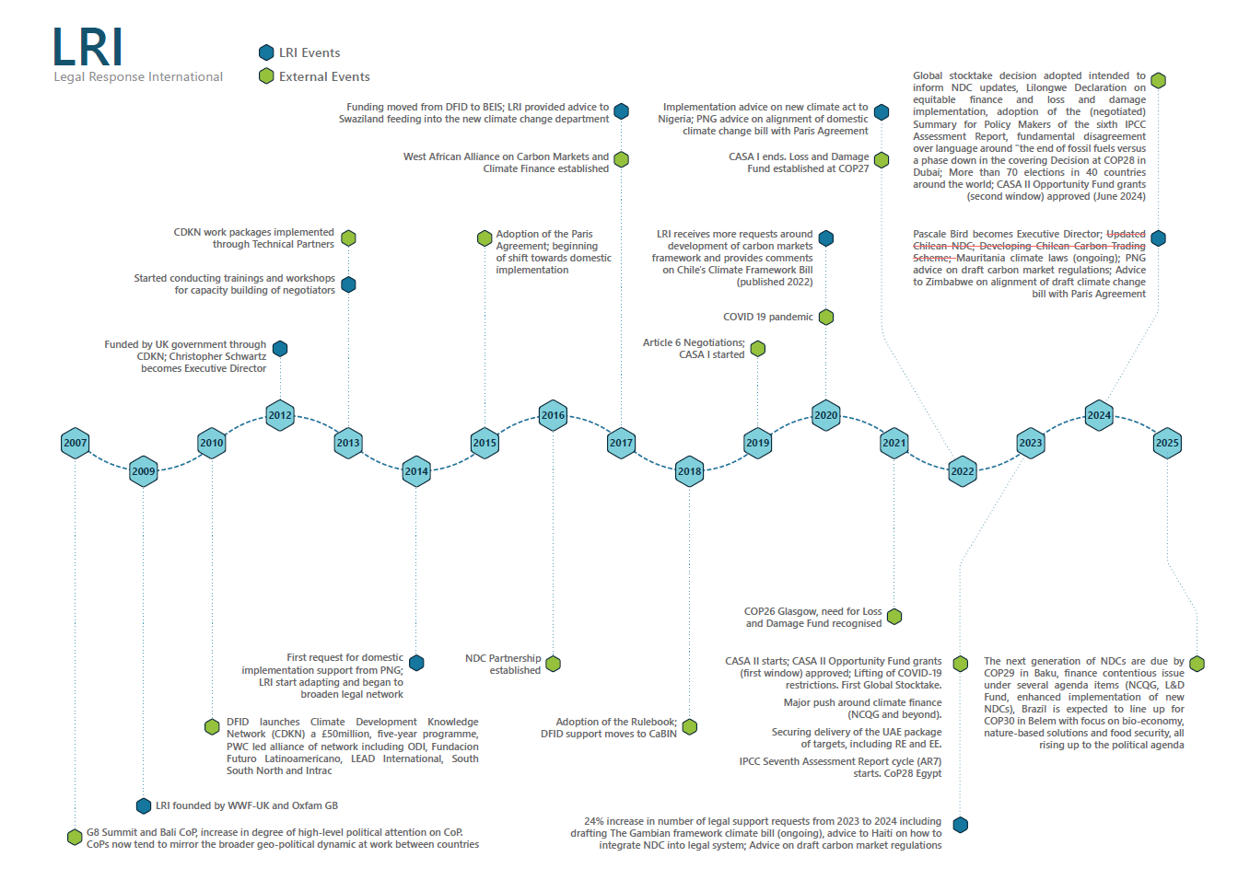

Figure 2. Timeline for the LRI case study

Case study 2: Legal Response Initiative
Outcome title  The expansion of a successful, innovative technical assistance model to serve Global South countries’ implementation needs | Strength of evidence  Strong

Summary of CASA II contribution
Very confident that CASA II made a critical contribution
LRI employs a unique operating model, providing pro bono, ad hoc, and targeted legal support across a wide array of legal issues related to domestic implementation. LRI has adapted its operating model to offer a broader suite of services through the niche of high-quality legal expertise—ranging from NDC support and drafting of climate legislation and carbon market frameworks, to conducting legal research and aligning domestic laws with international climate obligations.
CASA’s support, as the main funder currently accounting for 76% of LRI’s core funding, enabled LRI to expand its approach and evolve into the go-to organisation for legal advice and support within the climate space. Continuous funding from the United Kingdom (UK) Government for over 15 years has allowed LRI to maintain a consistent presence at climate negotiations and develop its stock of assets, which has led to an increase in demand for its services—solidifying its role as an essential provider of legal support to Global South country delegations.

Summary of the contribution of other actors and factors
- LRI has an agile operating model | - Critical contribution
- Increasingly expansive and engaged network of pro bono attorneys in a high-growth, strategically important area of legal practice | - Critical contribution
- Strong focus on domestic implementation in the context of the multilateral climate framework, focusing on delivery of NDCs | - Critical contribution
- Trusting relationships built up over time between negotiators and legal teams | - Critical contribution

Geographic and temporal context
The biggest shift in context during CASA II, of relevance to this case study, is from delegations solely demanding rapid legal advice for negotiations support during climate negotiations to, now, also seeking greater alignment of international law and COP decisions with domestic policy and implementation. This includes the development of NDCs every five years, climate change framework laws, and, more recently, carbon market frameworks. This shift resulted in a wave of a new type of request to LRI.
In northern countries, common law jurisdictions and private practice, pro bono work is often embedded in the professional culture, serving not only as an obligation but also as a form of professional development. Law firms from LRI’s existing network have been very supportive of this shift towards domestic implementation and have been actively seeking work in this space. This also marks a shift from the early years of LRI (2010–2015), when support from law firms had to be solicited. They now actively seek opportunities to support LRI.
Nevertheless, there are clear limitations to the extent in which international lawyers are familiar with legal frameworks in other countries, when advising on domestic implementation. LRI is looking to expand its legal network to include lawyers from supported countries to better respond to this. However, anecdotal evidence indicates that, in some Global South countries, there is no or little pro bono culture (with regards to legal advice), and thus the expansion of the legal network could come with the challenge of adapting the operating model further to pay legal fees to local experts for ‘low bono’ support.

What did LRI do?
LRI has adapted and extended its rapid legal advice operating model to support greater depth and duration of support outside of negotiations. The pro bono legal advice provided by law firms and other legal experts is instrumental to LRI’s operating model. While the LRI team members do respond to some requests themselves, including by drawing on a legal database containing hundreds of prior advice cases (an important asset), they have over time established an expansive network of more than 165 legal advisors across 16 countries to draw on to respond to requests on a pro bono basis. While originally developed for direct, often in-person, negotiation support delivered through its extensive legal network, LRI now also offers support on domestic implementation. This shift was realised by reaching out to the existing legal network and gauging legal partners’ level of expertise and interest for domestic implementation. The domestic implementation model largely operates on a basis like the negotiations support model, with countries submitting support requests to LRI, which are then addressed either through LRI’s in-house expertise or its legal network. The key difference lies in the depth and duration of support provided. While LRI typically acts as an intermediary between legal experts and the requesting party in its negotiations support model, the more intensive nature of domestic implementation requires longer term in-country support. This, for example, involves the drafting of a climate change framework law from scratch. The ability to respond to such a complex request highlights how far LRI has adapted its operating model to meet these new needs.
Requests for support to domestic implementation built on the stock of assets that LRI has created since 2010. This includes strong relationships and a high level of trust between LRI and country delegations, through a continued presence and involvement in the climate negotiations space and the consistent provision of high-quality legal advice. Requests for support on domestic implementation primarily come from countries that LRI has previously engaged with, either through ad hoc support provided to negotiators during UNFCCC meetings or through capacity-strengthening trainings and workshops it has conducted. For example, one CASA-supported interviewee stated they felt confident making an informal request for legal research to support the development of their carbon markets legislation because they had a strong pre-existing relationship with one of the LRI team members. Another interviewee who has been receiving support from LRI since 2021 mentioned that the LRI has kept them updated on the types of support it offers, which led to a request for further support on domestic implementation.
Due to the varying levels of expertise across jurisdictions, and the fast-paced changes in the climate negotiations space, LRI conducts trainings for lawyers to develop and maintain their knowledge base and grow their legal network. The training provided helps the legal experts that LRI relies on to stay informed of the most recent developments in climate negotiations. They are thus equipped to navigate the rapidly evolving climate landscape and can deliver quality, relevant advice. LRI has also developed training materials that can be reused and adapted for broader audiences as well. In turn, law firms benefit from engagement with LRI by receiving no-cost training in a high-growth, strategically important area of legal practice. Training has included webinars for members of the network in advance of COPs, as well as in-person sessions with more junior members of the network.
LRI also uses legal experts, in addition to the core team, to staff its team during negotiations. This has led to the existence of a larger community of LRI ‘staff members’ who are familiar with the operating model, and who accompany LRI to negotiations and step in when LRI needs extra support. LRI connects its legal teams to delegations where appropriate, building networks that country delegations can potentially draw on independently in the future. The staff volunteers are thus also provided the opportunity to build relationships with the country delegations during climate conferences.
LRI has quality control systems in place to ensure the highest standards of advice, which has helped build trust among the delegations it supports. This includes providing internal peer review of legal advice, ensuring the lawyers in its network have the necessary qualifications, and sending advice it is unsure of to a second advisor. LRI also conducts reviews of the advice provided.

Intermediate outcomes – What changed?
Over time, LRI has built organisational capabilities to a level where there is a perception of LRI as a significant institution within the UNFCCC regime. LRI has adapted to context, formalised relationships with specific countries (through MoUs), and drawn on its wide network. It is a credible organisation that operates beyond the capacity of its core team of three full-time staff members and one intern. Across supported countries, LRI is seen as a trustworthy, responsive, and flexible legal resource, filling gaps in negotiation support and domestic implementation. The legal network and deep, collective understanding of international climate law provide a unique value—particularly to countries with limited in-house legal expertise. LRI has responded to multiple requests for a widening array of services, including reviewing, analysing, and providing input to climate change and carbon market frameworks to ensure their alignment with Paris Agreement commitments, and supporting the development of NDCs. This formalisation of ways of working has included an MoU between LRI and The Gambia that meant that LRI supported Gambian negotiators at UNFCCC meetings, while also playing a significant role in domestic implementation. This involved the drafting of a Terms of Reference for The Gambia’s Carbon Trading Bill, contributing to the drafting process, and offering comments on the first iteration of the draft Bill, both through internal expertise and the wider legal network.
For over a decade, legal experts have supported Global South negotiators in narrowing the gap with counterparts from better-resourced delegations. This has enabled these negotiators to engage more confidently and effectively in international negotiations and place them on a more equal footing. At COP29, LRI provided support to two female Gambian lawyers from the Ministry of Justice—who are involved in legislative drafting—by setting up a WhatsApp group to answer questions and offer guidance during their first COP. In many Global South countries, the inclusion of legal experts in negotiation delegations remains uncommon due to limited resources.
Many of the ongoing relationships between LRI and delegations can be traced back to initial negotiator capacity strengthening. The main contact in the Burkina Faso delegation is a lawyer and adviser to the National Council for Sustainable Development who was first supported by LRI to attend the pre-COP26 training for lawyers in London in 2021. Following this, the lawyer has received continuous support from LRI on legal queries relating to the international climate negotiations on transparency. Recently, the lawyer became the delegation’s Team Leader for Article 6. In response, LRI expanded their support to include legal queries on that topic.
Several countries’ domestic legislation (Brazil, Burkina Faso, The Gambia, Haiti, Mauritania, Nigeria, Papua New Guinea, and Zimbabwe) now include increased climate ambition in policy text.

In Nigeria, LRI together with the Environmental Resource Centre facilitated the creation of a Legal Working Group (LWG) that provided legal advisory services to the government on the UNFCCC process. The LWG also contributed to the development of the Nigerian Climate Change Bill. It undertook a review and revision of the Climate Change Framework Bill 2017 with a view to ensuring its alignment with international treaties and its effectiveness to facilitate NDC implementation. Separately, LRI also provided comments on the Bill in 2018 and 2020.
As Burkina Faso has decided to develop a carbon market framework, it reached out to LRI for legal support on specific aspects on the implementation of Article 6 as a part of this new framework. The country also receives support from the World Bank, Global Green Growth Institute, and the West African Alliance for the development of their carbon markets framework. However, the type of support from the actors above differs from the type of support received from LRI. LRI’s support is more focused on guidance and explanations of the international context, facilitating the integration of international climate laws and outcomes in their domestic laws.

How effective were the TPs during the period?
LRI has been highly effective. It provides a highly valuable service at no financial cost to the supported party. Interviewees reported high-quality service, timely inputs, and ease of requesting support. All interviewees also reported some pre-existing relationship or interaction with LRI, which speaks to the relationships and trust that LRI has been able to build over the years. The high quality of service provided is evidenced by the positive feedback below received from key informant interviews (KIIs) with CASA-supported people who received legal advice from LRI for domestic implementation:
“It was really transformative for me to attend the training I did in London. It was the beginning of my collaboration with LRI and since this time we're still collaborating. I even introduced them to my bosses and said to them, this is the group that supports us when you ask for something.”
“The support I got has been very good on so many levels. It allowed us as a government to take stock and [see] how best we can plug that gap. Just to have an extra set of eyes [from LRI] has been able to give us confidence that we are on the right path.”
“It was excellent in terms of quality. They captured really well the needs that we were expressing in the questions and was very fast. It was done in a very short period of time.”
“There hadn’t been any cost with this interaction. This makes the support of LRI even more needed—you don’t have to pay anything. They are super knowledgeable about the issues they help us on.”
“Since this training, I have been supported, and I’m still supported. And I’m not the only one.”
Nevertheless, while the current model is very successful, LRI is constrained by the small size of its core team. The network it operates within allows it to respond to multiple legal requests, but there is a limit to how many of these it is able to process and respond to due to resource constraints within the core team. This is exacerbated by the necessary overlap in roles within the core team to maintain flexibility in delivery but constrains the amount of time available for strategic thinking. An area LRI would like to have additional support/resources on is in expanding the legal network of Global South experts to help tackle some of the challenges above. LRI representatives also state that the organisation could benefit from more junior members to handle coordination and free up time for senior members to think strategically about gaps, needs, and challenges such as strengthening lawyers in the Global South and building regional networks that they could tap into.

What were other advocates/actors doing during the same period?
Other actors such as the NDC Partnership, the United Nations Development Programme (UNDP), the World Bank (Climate Support Facility), and regional development banks—such as the Inter-American Development Bank (IADB), African Development Bank, and Asian Development Bank (ADB)—as well as bilateral programmes like UK Partnering for Accelerating Climate Transitions (PACT) and Deutsche Gesellschaft für Internationale Zusammenarbeit (GIZ)’s NDC Support Programme and other organisations with a tighter focus and smaller budget like the Global Green Growth Institute (GGGI), or consultancies like Climate Analytics (a CASA TP) and Climate Focus, all provide technical assistance in climate policy. However, the scope for legal support and implementation of international commitments domestically is more limited. Two interviewees confirmed receiving legal support for domestic implementation from other actors. First, Climate Analytics supported preparation of an NDC. Second, GGGI, the World Bank, and Climate Focus partnered with the West African Alliance on Carbon Markets and Climate Finance on the implementation of Article 6.4.
- The NDC Partnership is a global coalition including more than 130 countries established in 2016, which aims to support member countries in developing and implementing their NDCs by coordinating and facilitating support based on governments’ identified priorities and types of support needed. This technical support is provided at no cost to member countries as it is funded by bilateral and multilateral donors including ADB, the United Nations Food and Agriculture Organization (FAO), UNDP, the World Bank, the UK, Germany, and others. It is beyond the scope of this evaluation to ascertain whether countries that received support from LRI may have also received support from the NDC Partnership.
- The Climate Support Facility under the World Bank supports the development and implementation of NDCs and Long-Term Strategies.
- UK PACT supports the development and implementation of NDCs by providing technical assistance, capacity building, and resources to partner countries, among other technical assistance offerings.
- Countries and bilateral ODA donors may also have direct relationships with lawyers who may provide pro bono or low bono legal support.
- GGGI has provided some countries with policy advice and technical support in the development and enhancement of NDCs.
- Climate Focus is a for-profit consultancy that focuses on developing and implementing climate policies and interventions, including the implementation of carbon markets under Article 6, among other activities.
- Of a rather different nature, the Grantham Institute publishes an annual overview of key developments in climate litigation worldwide called the ‘Global Trends in Climate Change Litigation’ report. They also have an open access database on ‘Climate Change Laws of the World’, which details national-level climate change legislation and policies globally. This acts as a resource to lawyers worldwide.

What were the key factors in determining the outcome?
The agility of LRI’s operating model and trust-based relationships. LRI has effectively harnessed its pro bono legal resources and volunteer network, building on some 15 years of trust-based relationships developed with various countries and adapted to support in-country implementation. As a result, despite having a small core team, LRI is perceived as a vital, trusted source of legal expertise and can respond to an increasing number and diversity of requests each year. Together, these elements have helped establish LRI as a reliable organisation that delegations can turn to for a wide range of needs across all three workstreams: negotiations support, domestic implementation, and capacity building.
In 2023, Pascale Bird became LRI’s Director, taking over from Christopher Schwartz who led the organisation for over a decade. Notwithstanding this change in leadership, with the attendant risk of a loss of some important relationships, LRI continues to receive growing numbers of requests year on year.
Increasingly expansive and engaged network in a high-growth, strategically important area of legal practice. The existence of the pro bono legal system, and appetite from law firms to gain experience in the climate negotiations and domestic implementation space, has allowed CASA-supported countries to benefit at no cost to themselves. Interest from law firms has grown in recent years, driven by the rising prominence of climate policy and carbon markets, enabling LRI to tap into an increasingly expansive and engaged legal network. This mutually beneficial relationship enables LRI’s relatively small team to draw on a wide pool of quality-assured external experts to respond to the diverse range of requests they receive across both negotiations support and domestic implementation. At the same time, legal professionals can meet their pro bono commitments while gaining valuable experience and, to some extent, training in a rapidly evolving field. This organisational structure ensures that CASA-supported individuals receive high-quality legal assistance—support that would otherwise be difficult or costly to obtain.
Strong focus on domestic implementation within the global climate policy framework, specifically the delivery of NDCs. The broader shift in the climate landscape following the Paris Agreement—particularly the growing focus on domestic implementation to meet international commitments—has led to an increase in requests from country delegations for support on the alignment of domestic laws with international climate obligations. LRI mirrored this shift in its operating model to include offerings for domestic implementation.
Trusting relationships built up over time between negotiators and legal teams. There are strong existing relationships between negotiating groups, legal networks, specific country delegations, and climate-related alliances/regional coalitions. In addition, there is a large community of LRI members who are familiar with their offerings. These networks are the basis for delegations, where appropriate, to draw on independently in the future.
A constrained core team limits LRI’s potential contribution. LRI’s core team consists of three permanent staff and one intern. This limited capacity constrains the number of requests they can respond to, each of which are for highly valued legal services, particularly for more sustained support to domestic implementation. It also limits the time they can dedicate to strategise on scaling and tailoring its domestic legal support more effectively.

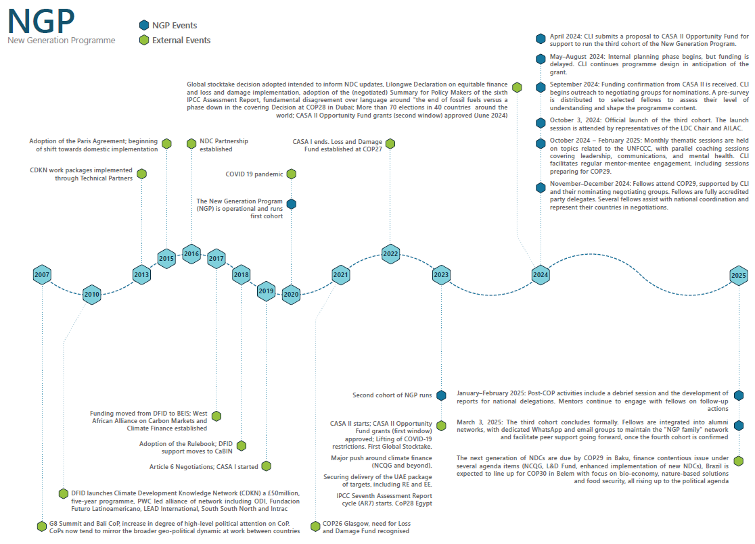
Figure 3. Timeline for the NGP case study

Case study 3: New Generation Programme
Outcome title:  A continuity model for climate leadership: Strengthening the negotiator ‘family’ among climate-vulnerable countries. | Strength of evidence  Strong

Summary of CASA II contribution
Very confident that CASA II made a critical contribution to the outcome
The CASA-funded third cohort of NGP marked a shift from an open-call youth fellowship to a negotiating group-nominated model, embedding young negotiators directly within party delegations. This evolution ensured stronger alignment between fellows and national priorities and resulted in all participants being accredited as official delegates at COP29. Alumni from previous cohorts returned as mentors and programme leads, establishing a self-reinforcing model of peer-led training and continuity. In summary, the programme demonstrated flexibility, strong coordination, and a clear commitment to participant needs. The third cohort appears to have been delivered effectively and credibly, reflecting a maturing model of negotiator development support.
NGP now functions less as a standalone initiative and more as a structured pathway into formal negotiating roles—particularly within the LDC Group. CASA II funding was critical to enabling this shift, supporting core staffing and wider thematic engagement. As a result, the programme has established a pipeline of young negotiators who are now contributing within three negotiating groups, where NGP is increasingly seen as a reliable source of expertly curated climate negotiation preparation.
A wide set of reinforcing factors shaped the outcomes of the third cohort of NGP, but many were supported, directly or indirectly, by CASA. Overall, we see that CASA’s support came in at a strategic point for both CLI and CASA, but that NGP’s credibility, and overall stock of assets, had been built during the previous cohorts.

Summary of the contribution of other actors and factors
- Convening power of the Director of CLI and the Loss and Damage Collaboration (L&DC) | Critical contribution
- Presence of alumni and informal allies as mentors | Critical contribution
- Support from other funders | Critical contribution
- Negotiating group buy-in and use of the nomination model | Important contribution
- Ability of CLI to set direction and evolve | Important contribution
- Delivery capacity and resilience | Important contribution
- Contribution of CASA II TPs to process | Important contribution
- Wider momentum behind youth participation | Some contribution

Geographic and temporal context
NGP has evolved as a Global South initiative, initially focused on young negotiators from African countries and subsequently expanding to a broader regional representation. The first and second cohort were dominated by African fellows, reflecting the existing networks of CLI and L&DC, as well as available funding streams. However, by the third cohort (2024–2025) CLI had intentionally widened participation to include fellows from South Asia and other regions, reflecting a shift toward a more inclusive and globally representative programme.
This geographical broadening was both a strategic and values-driven choice, underpinned by a recognition of shared structural challenges faced by young negotiators across Global South regions. Fellows in the third cohort included individuals from countries such as Rwanda, Fiji, Ethiopia, and across South Asia, all of whom were nominated by their respective negotiating groups. This reflects the programme’s ambition to cultivate a diverse leadership pipeline that spans regional groupings such as LDC, AOSIS, the Independent Alliance of Latin America and the Caribbean (AILAC), and AGN.
NGP has been in operation since 2020, with each cohort building on the lessons and networks of the one before. The third cohort, implemented from October 2024 to March 2025, marked a significant maturation of the programme, showcasing deeper negotiating group buy-in, greater operational independence, and expanded geographic reach.

What did NGP do?
CLI and L&DC collaborated to implement the third cohort of the existing NGP, developing a joint proposal for CASA II’s OF in 2024. CASA II supported the third cohort of eight fellows, following the second and first cohorts in 2023 and 2020, respectively.
The third cohort comprised eight young negotiators from Dominica, Burundi, Guinea, Kenya, Panama, Peru, Samoa, and South Sudan. Nominated by the AGN, AILAC, AOSIS, and LDC Group, they participated in a six-month programme combining monthly thematic workshops, coaching calls, and tailored one-to-one mentorship.
Mentorship was central to the model. Each fellow was paired with an experienced negotiator who provided ongoing guidance both during the training period and throughout COP29 itself. Mentors helped fellows navigate the complex UNFCCC process, access key sessions, and translate technical knowledge into negotiation strategy. This personalised support was consistently cited by fellows as one of the most valuable aspects of the programme.
At COP29, seven of the eight fellows joined their national delegations and engaged directly in negotiations. They took on formal roles across agenda items including Article 6, Loss and Damage, and transparency. Rogelio Campos (Peru) intervened during Article 6.2 discussions, while Kevin Polo (Panama) presented on Panama’s biennial transparency report. Others contributed to internal coordination, attended bloc strategy meetings, and participated in side events. They were joined by alumni from earlier cohorts—now totalling 28 negotiators from 21 countries—several of whom have progressed into senior roles, including national UNFCCC focal points and LDC Chair advisers.
To support fellows and wider Global South negotiators, CLI and L&DC produced over 25 formal outputs during COP29, including key messages, daily updates, negotiation ‘cheat sheets’, and a Loss and Damage finance briefing. A COP29 outcome brief was released within hours of the close.

Intermediate outcomes – What changed?
NGP has transitioned from an experimental initiative to a structured and strategic pipeline for developing country negotiators. Evidence from the third cohort demonstrates clear contributions across CASA II’s three pathways of change.
Capacity and institutional strengthening
NGP has become a strategic asset to Global South negotiating groups seeking to build resilient, homegrown negotiating capacity. The shift in cohort three to a nomination-based selection process—implemented in collaboration with the LDC Group, AILAC, AOSIS, and AGN—marked a step change in how CLI aligned individual skill-building with institutional strengthening. Fellows were not only trained as individuals but positioned as functional members of their delegations, accountable to bloc leadership and directly involved in negotiation processes at SB62 and COP29.
This closer alignment has strengthened group cohesion, reduced reliance on external TPs, and enabled blocs to begin cultivating internal pipelines of talent. CASA II’s investment in NGP at this stage reflects a strategic and forward-looking approach: rather than delivering one-off training inputs, the programme supports a replicable, politically grounded model of climate diplomacy that is shaped by and for developing country actors.
The LDC Group has become a key institutional beneficiary of this approach. Several alumni from the first two NGP cohorts are now embedded within the Group’s structures and contributing directly to its negotiating function. Brenda Mwale (Malawi), a cohort one alumna currently serves as Climate Diplomacy Advisor to the LDC Chair. She provided orientation and strategy support to the third cohort ahead of COP29, helped fellows understand bloc priorities, and facilitated their integration into LDC coordination meetings. Her position bridges technical support, political messaging, and mentorship.
Honorine Isingizwe (Rwanda), alumna of first cohort, now serves as Coordinator of the New Generation program. She led the design and delivery of the third cohort’s curriculum, managed liaison with chairs of four negotiating groups (AGN, AILAC, AOSIS and LDC), and oversaw mentorship pairings—thus ensuring the programme responded dynamically to real-world negotiation demands, with a focus on providing support to the fellows and alumni to effectively participate in the negotiations process.
Justina Áurea Da Costa Belo (Timor-Leste), New Generation Program founding member, former IIED fellow, successfully coordinated the New Generation Program’s second cohort. She also played a key role in supporting the Least Developed Country (LDC) Group position on Loss and Damage, contributing to negotiation strategies and mentoring emerging climate leaders during COP 28. She is now Communications Co-lead shaping communications to reflect the programme’s diffusion of influence beyond its core participants.
Olivier Ishimwe (Rwanda) from cohort one has become the LDC Group’s co-coordinator for Article 6 and its alternate member on the Article 6.4 Mechanism Supervisory Body. He continues to mentor NGP fellows on carbon market architecture and governance, helping them connect to high-stakes technical spaces.
Taken together, these trajectories reflect how the NGP has evolved into an institutional backbone for the LDC Group—creating continuity across negotiation cycles and cultivating a generation of negotiators who are now central to the process.
Access to and engagement in negotiations
The third cohort’s full access to COP29 negotiations enabled more meaningful participation. Seven of the eight fellows attended COP29 (one withdrew due to illness), with all actively engaged in formal processes. Rogelio Campos (Peru) made an intervention in the Article 6.2 negotiations, while Kevin Polo (Panama) spoke during the biennial transparency report dialogue. Fellows joined bloc coordination meetings, participated in contact groups, and contributed to strategic briefings. Post-COP reflections confirmed that mentorship, thematic workshops, and targeted coaching strengthened their ability to track negotiations, align with bloc messaging, and respond in real time to negotiation dynamics.
Prakriti Koirala (Nepal), also from cohort one, and a mentor of 2nd cohort of the program, acts as a youth coordinator to the LDC Group at COP29, she supported the production of real-time messaging, and thematic analysis. Working alongside CLI communications co-lead Justina Áurea Da Costa Belo (Timor-Leste), she helped shape public visibility, extending institutional capacity not only in negotiations but in framing their narrative.
Support to implementation and review mechanisms
The March 2025 L&DC submission to the ‘Baku to Belém Roadmap to 1.3 trillion’ was shaped in part by outputs and insights generated through NGP. Fellows and alumni contributed to earlier messaging and analysis on the NCQG, including briefing materials and cheat sheets used by delegations. This submission exemplifies how fellows’ contributions are beginning to influence how global frameworks are interpreted and operationalised in vulnerable countries.

How effective was the implementation of NGP?
Based on the evidence available, the delivery of the third cohort of the NGP appears to have been highly effective overall. Despite operating in a challenging context—with delayed funding, political nomination processes, and a crowded global negotiation calendar—CLI and L&DC delivered a coherent, timely, and well-regarded programme that was aligned to the needs of negotiators.
Coordination between CLI and L&DC functioned well, even as both partners managed competing priorities across Loss and Damage processes, the NCQG, and broader 2024 summits in what has been acknowledged as a particularly busy year. The team delivered pre-COP workshops, real-time negotiation support, and communications outputs, while maintaining close relationships with negotiation group leadership. This suggests a delivery model that, while lean, was sufficiently robust to meet the demands of the programme.
There were, however, several delivery challenges. The most significant was the delay in receiving nominations from negotiating groups. This created a compressed onboarding window and limited the time available for structured preparation. Although CLI adapted quickly—revising the training schedule and leveraging alumni support—this bottleneck likely reduced the depth of early engagement. Similarly, CASA’s delayed disbursement of funds meant that some activities had to be initiated before resources were fully confirmed, introducing risk and limiting advance planning.
Operational issues such as time zone coordination and language accessibility also posed challenges. Fellows were located across widely different time zones, and several Francophone participants had limited English fluency. However, the delivery team responded proactively by introducing staggered sessions, sharing recordings, offering bilingual peer support, and simplifying language use where possible.

What were other advocates/actors doing during the same period?
While other youth-focused initiatives were active during the same period—such as AGNES, the Climate Youth Negotiators Programme, and Oxfam’s Youth Climate Negotiators Academy—coordination across these programmes remained limited. Interviewees suggested that, while some of these initiatives aimed to achieve similar goals, many lacked the continuity, independence, or deep negotiating group relationships that defined NGP’s model.
Efforts to build alliances with other programmes encountered barriers, including varying degrees of readiness to collaborate, differing visions, and institutional silos. CLI reached out to create shared channels and conversations but found that many initiatives sought curated support without contributing shared learning or strategic coordination.
Additionally, criticisms were raised about the role of some established organisations. Interviewees noted that historically, these actors—though highly influential—were at times perceived as gatekeepers in the space, inhibiting more locally led or youth-driven initiatives. Specific concerns were raised about exclusionary practices and the lack of equitable recognition of contributions by negotiators from the Global South. While some individuals were recognised as key allies and mentors, broader institutional dynamics were critiqued for perpetuating ‘colonial tendencies’ and power asymmetries.
These critiques underscore the importance of independent, youth-led initiatives like NGP, which aim to shift those dynamics by embedding young negotiators directly into decision-making spaces.

What were the key factors in determining the outcome?
CASA II’s contribution to the third cohort of NGP appears to have been both catalytic and well timed. Based on available evidence, the OF grant enabled delivery of the third cohort at a pivotal moment, supporting the programme’s shift from an open-call youth fellowship to a nomination-based model embedded within negotiating group structures. Without this funding, the third cohort would likely not have gone ahead.
CASA’s support can be understood in two dimensions. Directly, it provided a combined grant to CLI and L&DC, which—although submitted as separate proposals—were merged into a single award on the recommendation of the CASA programme team due to close operational ties and shared leadership under Erin Roberts. This consolidation improved administrative efficiency but also complicated CLI’s strategic ambition to establish greater operational independence from L&DC, including diversifying the programme’s thematic focus beyond Loss and Damage.
The CASA grant, confirmed in October 2024, underwrote staffing, communications, and programme delivery for the third cohort. It enabled CLI to professionalise operations and invest in centralised support, including two communications leads, a dedicated programme coordinator, and administrative capacity. Importantly, the additional resourcing allowed CLI to broaden NGP’s thematic scope beyond Loss and Damage, responding to a longstanding objective to reflect the full range of issues faced by young negotiators from the Global South.
At the same time, CASA’s role should be viewed as part of a longer trajectory. While its support was critical to the third cohort, CASA was not involved in the design or delivery of the previous cohorts, nor in the foundational community building that underpins the programme. CLI’s credibility, networks, and delivery capacity have been developed incrementally since 2020, primarily through earlier investments and alumni engagement. CASA contributed approximately two-thirds of the third cohort’s costs but did not build the social and technical capital that made the programme viable. Its role in the broader NGP story is therefore meaningful but recent.
CASA’s contribution also extended through indirect channels. The selection of fellows for the third cohort drew on CLI’s collaboration with four negotiating groups—LDC, AILAC, AOSIS, and AGN—three of which receive core support under CASA’s Work Package 2. While CASA TPs were not directly involved in the nomination process, ongoing CASA support appears to have enabled these groups to engage meaningfully. In the absence of this support, it is unlikely they would have had the institutional capacity or incentives to participate in a structured, group-led fellowship.
Furthermore, several individuals who shaped or delivered NGP have longstanding links to CASA-funded organisations. Erin Roberts (CLI and L&DC founder) previously worked with ODI and IIED during periods when both were funded under CASA. Communications Co-Lead Prakriti Koirala and her colleague Justina Áurea da Costa Belo are both NGP alumni and former IIED fellows, while Camilla More (IIED) served as a pro bono mentor and advisor to the programme. Although these links were not orchestrated by CASA, they reflect a shared ecosystem of practice that has benefitted from CASA funding.
Finally, the relationship between NGP and CASA is reciprocal. NGP has generated tangible value for CASA-supported groups, particularly the LDC Group. Several NGP alumni are now embedded in national and negotiating group roles, where they contribute to communications, coordination, and technical functions, reinforcing CASA’s broader support for negotiation effectiveness. In this way, NGP has enhanced continuity and institutional memory within CASA’s priority constituencies, demonstrating how targeted investments in youth leadership can yield broader systemic gains.
In sum, CASA’s support to the third NGP cohort was timely, enabling, and mutually reinforcing—integrated within a wider landscape of actors and relationships that have shaped the programme’s success to date. While not the architect of NGP, CASA played an important enabling role in its most recent phase.
Other factors: Foundations of credibility
The strength of the NGP model rests heavily on investments and relationships that predate CASA’s direct involvement:
Leadership and vision of Erin Roberts: As the founder of CLI and L&DC, Erin Roberts has played a foundational role in shaping NGP’s structure, strategy, and ethos. While her leadership predates CASA involvement, the OF grant helped consolidate her vision by enabling the third cohort to scale. CASA funding allowed her to formalise staff roles and support CLI’s strategic aim of decoupling from L&DC, giving her greater autonomy to steer the programme.
Alumni and informal allies: The growing alumni network—including figures such as Honorine Isingizwe, Justina Áurea Da Costa Belo and Prakriti Koirala in leadership roles—has ensured continuity, credibility, and peer-led delivery. While this network existed before CASA’s involvement, its activation during the third cohort was made possible through CASA’s funding of programme coordination roles and mentorship activities. The funded staff were critical in designing and implementing a cohort model that placed alumni at the heart of delivery.
Negotiating group buy-in and active participation: Support from the LDC Group, AILAC, AOSIS, and AGN was essential to nominating and embedding fellows. While this was enabled by CLI’s own relationships, CASA’s ongoing support to three of these groups through its negotiation support work indirectly helped create the conditions for their participation. Without that broader investment in these groups’ capacity and coordination, the nomination process may have lacked momentum or legitimacy.
Flexible support from other funders: Prior support from organisations such as Oxfam and Practical Action enabled earlier cohorts and contributed to the legitimacy of the model. CASA’s entry as a funder reinforced this foundation, offering a level of institutional recognition that further strengthened CLI’s fundraising case. The CASA grant also allowed the programme to diversify beyond its initial Loss and Damage focus, signalling to others that NGP had broader strategic value.
Wider momentum behind youth participation: The third cohort benefitted from an overall shift in the climate diplomacy space toward supporting young negotiators from the Global South (see Table 1 for some example initiatives). CASA did not create this trend, but it responded to it in a way that helped consolidate it. By backing an initiative like NGP, CASA provided practical reinforcement to this global momentum, while its emphasis on alignment with negotiation groups helped distinguish NGP from more ad hoc youth initiatives.
The ability of CLI to set direction and evolve: CLI’s decision to diversify the programme’s scope, embed it within group structures, and ensure alumni retention was crucial to its maturity. CASA played a facilitating role in this evolution by enabling CLI to formalise leadership roles and pursue greater independence. The structure of the OF grant allowed CLI to retain control over programme design, while gaining the resourcing necessary to strengthen its delivery.
Delivery capacity and resilience: The third cohort was implemented under tight timelines and logistical pressure, yet CLI delivered a well-regarded and fully integrated programme. CASA’s funding enabled the hiring of key staff who managed training, communications, and alumni engagement. While much of CLI’s delivery capacity was rooted in experience from earlier cohorts, CASA’s support was pivotal in translating that capacity into a high-quality, six-month programme.

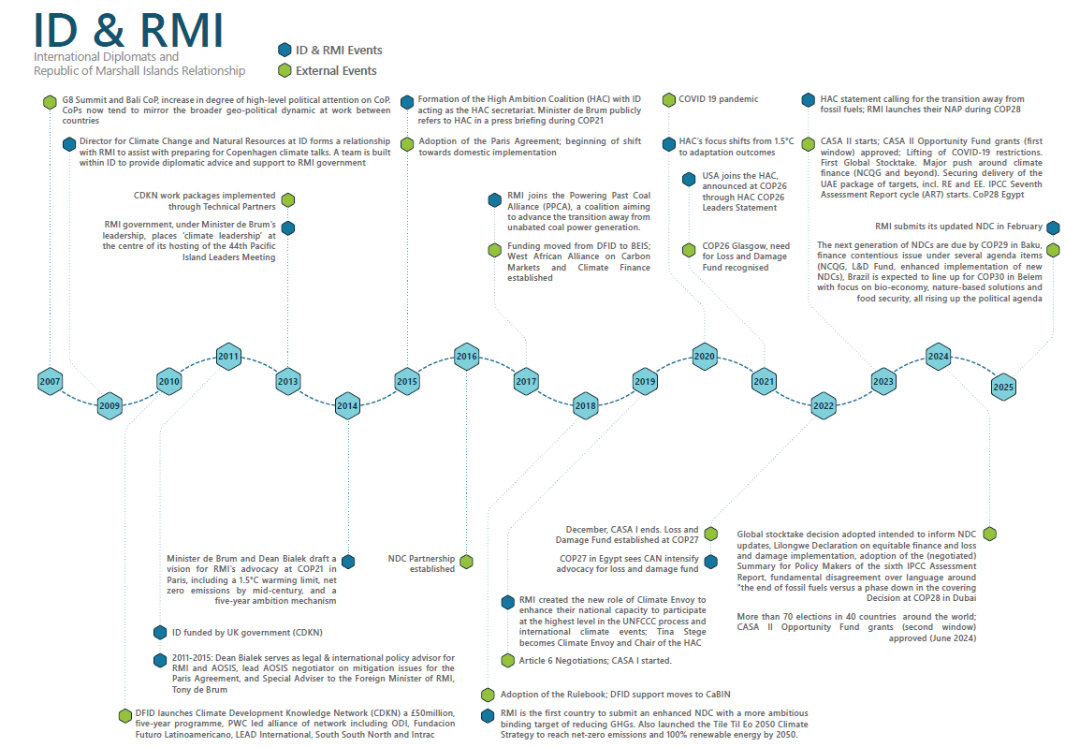
Figure 4. Timeline for the RMI-HAC case study

Case study 4: Republic of the Marshall Islands and the High Ambition Coalition
Outcome title  Sustained leadership by the Republic of the Marshall Islands (RMI) as the convenor and chair of the HAC influences the outcomes of negotiations | Strength of evidence  Some evidence

Summary of CASA II contribution
More confident than not that CASA II made an important contribution to the outcome
After the Paris Agreement was secured, Independent Diplomat continued to provide critical capacity and resources as the Secretariat of the HAC and to RMI directly. The country could continue to fulfil its role as convenor and chair of the HAC, while also starting to transition RMI staff into key HAC Secretariat roles.

Summary of the contribution of other actors and factors
- The longstanding relationship between RMI and Independent Diplomat was pivotal in securing ambitious negotiation outcomes | Important contribution
- RMI was already established as a leader and a notable actor with political resources and capacity to take forward the country’s interests and mandate within HAC and the broader climate regime | Important contribution
- Other actors such as Saleem Ul Huq (deceased 2023), the LDC Group, civil society at large, and CYNP (youth negotiator training) played a more crucial role in climate ambition than Independent Diplomat | Critical contribution
- Others provided greater funding to RMI/other HAC actors | Some contribution
- The size of RMI—a small island nation population—means that sustainability is constrained | Some contribution

Geographic and temporal context
For this case study, the temporal period includes the run-up to COP28 in Dubai in 2023, COP28 itself, and other key events in the climate regime prior to and during COP26.
Under the leadership of the late Minister Tony de Brum (1945–2017), the RMI government placed ‘climate leadership’ at the heart of its hosting of the 44th Pacific Island Leaders Meeting, marking a new chapter in RMI’s climate diplomacy two years ahead of the Paris Agreement. Minister de Brum’s strong advocacy for the 1.5°C target, along with the founding of the HAC at COP21, laid the groundwork for RMI’s continued active engagement in UNFCCC negotiations.
One of the biggest wins for RMI and the HAC since the Paris Agreement came at COP26 in Glasgow (2021), with the agreement to double adaptation finance by 2025. Much of the HAC leader statement issued at the start of COP26 was replicated in the Glasgow Climate Pact, including text on a phase-down of unabated coal and inefficient fossil fuel subsidies, and the doubling of adaptation finance, which were taken directly from the HAC statement, showing a clear line of influence:
‘Within the High Ambition Coalition, we campaigned hard from dawn to dusk to secure a doubling of adaptation financing. When the High Ambition Coalition launched this call, we didn’t know if it would be possible, it was a very hard-fought win,” said Marshall Islands Climate Envoy, on twitter’
The HAC Secretariat was approached by the COP Presidency team and HAC ministers with a request for support to drive results at COP26. The first HAC ministerial meeting took place in July, and Independent Diplomat began working with ministers and the HAC Secretariat to develop a public statement outlining the Coalition’s priorities, including decarbonisation and adaptation finance. Independent Diplomat supported the organisation of two key ministerial meetings ahead of COP to publicly shape the HAC agenda and issued a public response to the IPCC Working Group report, gathering signatures from HAC members to demonstrate coordinated climate leadership. As COP26 approached, Independent Diplomat also started to rally core HAC members and developed an open letter to the G20, setting out asks on decarbonisation and the doubling of adaptation finance.
As the HAC Secretariat, Independent Diplomat also played a behind-the-scenes diplomatic role in encouraging the US to rejoin the HAC under the Biden administration—an effort made more delicate by the complex historical relationship between the US and RMI, shaped by nuclear testing and broader Pacific geopolitics. They started by meeting with the US delegation and introduced them to RMI negotiators, including the RMI Climate Envoy. Independent Diplomat supported the organisation of these meetings, monitored domestic political developments in the US, assessed The US’ readiness to meet the HAC’s standards for membership, and coordinated with RMI negotiators on the best way to approach the inclusion of the US as a HAC member. They then worked with US negotiators to deliver this.
The US officially joined during COP26, coinciding with the release of the HAC COP26 Leaders’ Statement in week one. The Statement, which initially had around 20 signatories, grew to over 50 by the end of the week, leveraging the media coverage of the inclusion of the US to garner more support and add more signatures. They also conducted a semi-recruitment event featuring President Obama, who highlighted the importance of the HAC in driving ambition at Glasgow.
The HAC was able to leverage this support to negotiate an increase in finance for adaptation. These efforts contributed significantly to shaping the Glasgow Climate Pact, with several elements from the HAC statement reflected in the final text, including the phase-out of fossil fuel subsidies. Although the final text on coal was watered down at the last moment, the HAC’s advocacy facilitated the agreement on fossil fuel phase-out and adaptation finance.
At COP28, RMI again played a prominent role, supported by Independent Diplomat through press coordination, meetings facilitation, and its role as HAC Secretariat to build momentum for phasing out fossil fuels. This included publishing the Leaders Letter to the G7 and securing strong media coverage for RMI’s National Adaptation Plan (NAP) launch. Independent Diplomat helped align developed and developing countries within the HAC, contributing to progress on the GGA framework.

What did Independent Diplomat do?
In its Secretariat role for the HAC, Independent Diplomat supports RMI as the HAC convenor by managing day-to-day logistics, preparing statements and screening notes, and advising on strategic direction, including expansion of the HAC's agenda to emphasise adaptation. Through technical diplomacy, ID supports building alliances, coordinating outreach, and facilitating member engagement to secure outcomes such as the commitment to double adaptation finance agreed at COP26. It assists in identifying and approaching new HAC members, balancing representation between developed and developing countries, and ensuring that group strategy reflects the needs and ambitions of all members. It shapes the strategic direction of the HAC under the direction of the RMI government.
When the Secretariat is interested in incorporating new members into the HAC (e.g. to build support for a statement), members may first approach the target country in the margins of climate conferences and invite them to observe a meeting of the HAC and have an initial bilateral discussion. They have also conducted outreach tours in the past in target regions to engage countries and ensure alignment with particular statements and the overall HAC ambition.
In 2020, Independent Diplomat, as the HAC Secretariat, pushed to widen the scope of the HAC from being primarily focused on achieving the 1.5-degree goal to include adaptation. There was interest from developing country members on adaptation, particularly after the focus of COP21 on its importance. While Independent Diplomat did not directly engage in discussions between developing and developed country members, it did provide technical support to help RMI teams prepare for those meetings.
Independent Diplomat has been providing climate diplomacy support to RMI since 2009. Each year, it co-develops an annual workplan with the RMI Climate Envoy, ensuring that strategic priorities are aligned with both political and technical leadership. It offers ad hoc technical training, strategic coaching for negotiators and politicians, and ongoing mentorship for emerging leaders, while positioning its contribution as “strengthening existing capacities” rather than providing formal capacity building. This includes securing interview opportunities for RMI’s Climate Envoy, Tina Stege, coordinating the scheduling, and preparing her with talking points in advance. Emphasis is placed on bi-directional capacity strengthening when an Independent Diplomat team member is partnered with an RMI counterpart. The funding from CASA also allows RMI delegates to attend intercessional meetings such as the SBs in Bonn.
The type of support Independent Diplomat provides has adapted in response to specific requests from RMI, largely driven by the trust-based relationship between the two parties. In 2020, it received feedback from the Marshallese team that there was an appetite and interest in Marshallese negotiators taking over from Independent Diplomat during negotiations and developing the capacity of young Marshallese negotiators to represent RMI whenever possible. This shift was largely attributed to one of RMI’s climate envoys. Instead of Independent Diplomat being at the forefront of negotiations, then, it now provides backstopping and logistical support to the RMI team, allowing the RMI team to be responsible at a technical level during negotiations. There was also a request to increase climate finance support. In response, in 2022 Independent Diplomat brought in a full-time climate finance expert. It also played a critical supporting role by bringing in experts with adaptation and gender expertise, helping to establish and then strengthen RMI’s internal capabilities over time.
Much of the support it provides to RMI (beyond strategic advisory support and training) is viewed to be essential ‘logistical’ or ‘administrative’ support, which the RMI team could potentially do if only they had a larger delegation. This, however, is constrained by the small population size of RMI (~40,000 people). KIIs suggest that it would be near impossible to operate at the same levels if CASA support were removed and RMI had to rely only on internal resources, as there simply is not enough people.
In addition to providing administrative support, Independent Diplomat also supports domestic implementation within RMI. It supported the development of RMI’s NAP by handling media and reviewing drafts to ensure the document aligned with both domestic and international law. As stated above, the NAP was published in 2023 at COP28.
After COP29, Independent Diplomat also supported the development of RMI’s latest NDC by creating the initial framework and, through in-country consultations and drawing on the NAP, supported the drafting and flagging where new information was still needed. RMI identified where parts of the NDC could be drawn from existing work, such as the sections on adaptation and Loss and Damage, thereby reducing the need for inputs. Independent Diplomat conducted weekly meetings focused on the NDC and was consistently engaged throughout the development process. The NDC update was successfully published in February 2025.

Intermediate outcomes – What changed?
RMI has consistently been described as ‘punching above its weight’ at UNFCCC and International Maritime Organisation negotiations, where it has played a leading role in raising ambition and building consensus between developing and developed countries through leadership of the HAC.,, Through consistent support to RMI’s climate diplomacy since 2009, Independent Diplomat has played a role in strengthening, sustaining, and highlighting RMI’s capacity to lead in the climate negotiations space.
Dubai COP28 – Phase-out of fossil fuels
The outcome in Dubai marked another turning point, with language on transitioning away from fossil fuels included in the final agreement for the first time. RMI played a pivotal role in securing this result through sustained advocacy for climate ambition and justice in the lead-up to COP28 and throughout the negotiations. The HAC, led by RMI, was also instrumental in achieving this outcome—organising multiple formal and informal convenings during COP that enabled a strong, coordinated pushback against the initial weak text proposed by the COP presidency. This effort helped forge a unified stance within the HAC, bridging developed and developing country members around the importance of phasing out fossil fuels.
During COP28, Independent Diplomat supported the RMI delegation by coordinating press engagements, facilitating both informal and formal meetings, and acting as the HAC Secretariat to strengthen momentum behind the fossil fuel phase-out. This included publishing the Leaders Letter to the G7, which called for a global phase-out of fossil fuels. Independent Diplomat also secured widespread media coverage for RMI, including prominent reporting of remarks by RMI’s Head of Delegation, Hon. John Silk—such as the widely quoted line, “we will not go silently to our watery graves”—which were drafted and/or distributed to the press by Independent Diplomat. They also secured media attention for the launch of RMI’s NAP at COP28. As HAC Secretariat, Independent Diplomat further facilitated coordination between developed and developing country members, which was critical in advancing the Global GGA framework at COP28.

How effective were the TPs during the period?
The monitoring, evaluation, and learning team were unable to interview Dean Bialek, who led Independent Diplomat’s work with RMI in the period 2008–2016. However, a partner confirmed the role that the organisation played in achieving ambitious climate outcomes: “Independent Diplomat was very involved from the start and was sort of playing in the background but influencing the strategy and the approach from the beginning.”
There was also further validation from a KII on Independent Diplomat’s role in amplifying voices from RMI: “I don’t know that [RMI] would be at the table [without CASA support] – [RMI] certainly wouldn’t be at the table in the same way”. They also stressed the importance of climate-vulnerable countries having access to climate negotiations: “If the Marshall Islands wasn't at the table… or other CASA beneficiaries… if you didn't have those voices in these spaces, then I don't know that we would have a Paris Agreement with 1.5 [degrees]. I don't know that you'd have almost any initiative of ambition, because the most vulnerable countries have pushed it.”
Independent Diplomat’s role as the HAC Secretariat and RMI’s role as convenor and chair of the HAC have significantly contributed to RMI being continually invited to attend key events that other nations of the same size are not typically invited to. A KII stated: “To be consistently invited to every meeting as Marshall Islands because of [RMI’s] role as chair of the HAC, I just don't see that that would have happened if [RMI] didn't have the support [from Independent Diplomat] as the HAC Secretariat.”
Independent Diplomat’s role as the convenor of the HAC and in supporting the RMI delegation with logistics and administration is highly valued. Stakeholders have indicated that, without its support, RMI would not be operating at its current level and would struggle to manage the volume of meetings and substantive work required to engage meaningfully in international negotiations.

What were other advocates/actors doing during the same period?
One of the key factors cited that influenced the decision at Glasgow on doubling adaptation finance was the election of the Biden administration in the US. The US delegation, led by John Kerry, became a key player in bolstering support for the HAC from other countries that may not necessarily have otherwise been on board.
Climate Action Network (CAN), which is a global network of civil society organisations in over 130 countries, led a concerted campaign to push the agenda to establish a Loss and Damage Fund onto the negotiating table at COP26 in Glasgow. CAN mobilised pressure and coordinated with negotiating groups such as AOSIS, AGN, and key countries within the LDC Group. Under Pakistan’s leadership of the G77+China, the bloc also presented a united front in calling for the establishment of the Loss and Damage Fund.
CAN continued and intensified its advocacy leading up to COP27 in Egypt. The alignment between civil society actors such as CAN and the G77+China resulted in a “political partnership”. One interviewee mentioned that this partnership was key in overcoming resistance, particularly from developed countries within formations like the HAC, who were seen as blocking progress for the establishment of the Fund.
At COP28, CAN and allies once again built broad coalitions, conducted direct engagement with country blocs, and elevated fossil fuels to a top-tier issue—despite its previous marginal presence in UNFCCC discussions. The only prior mention had come in Glasgow, where coal was singled out controversially.

What were the key factors in determining the outcome?
The longstanding relationship/alliance between RMI and Independent Diplomat was pivotal in negotiation outcomes. Independent Diplomat has a longstanding relationship with RMI and has been providing climate diplomacy support to RMI since 2009. The organisation’s leadership at the time acted as the legal and international policy advisor for the RMI and AOSIS, as the lead AOSIS negotiator on mitigation issues for the 2015 Paris Agreement, and as Special Adviser to the (late) Foreign Minister of RMI, Tony de Brum. This support has continued through to CASA II, and the sustained support has allowed RMI to strengthen its own internal capacity. This has been evident with RMI Climate Envoy Tina Stege, who was named as one of the seven people to watch at COP28, leading to RMI negotiators being at the forefront during climate negotiations.
RMI was already established as a leader and a notable actor with political resources and capacity to take forward their interests and mandate within the HAC and the broader climate regime. In 2013, the RMI government placed ‘climate leadership’ at the centre of its hosting of the 44th Pacific Island Leaders Meeting. The summit brought together high-level international climate and energy experts, as well as envoys from the US, EU, China, and beyond, to engage directly with Pacific Heads of State and witness firsthand the existential threats climate change poses to low-lying atoll nations. Buoyed by heightened media attention, RMI was subsequently invited to join informal climate talks with the Major Economies Forum on Energy and Climate, a space typically reserved for the world’s largest economies and emitters.
Other actors such as Saleem Ul Huq, the LDC Group, and civil society organisations like CAN and CYNP (youth negotiator training) played a more crucial role than Independent Diplomat. The late Prof. Saleem Ul Huq was also named as a highly influential actor in advocating for the 1.5°C goal, evidenced across multiple KIIs. Huq, who was the Founder and Director of the International Centre for Climate Change & Development in Bangladesh at the time, was widely respected across negotiating groups and was pivotal in amplifying calls for the 1.5°C goal. As evidenced by KIIs, Prof. Huq gathered support through informal spaces prior to COP21. While the late Minister Tony de Brum and Independent Diplomat played a key role in rallying support for the Paris Agreement, its adoption was shaped by a range of actors. The French COP Presidency played a central diplomatic role, with France's Climate Change Ambassador and Special Representative for the 2015 COP21 emerging as a key figure in managing the negotiations and shaping consensus. The longstanding alliance between the EU and AOSIS, which was solidified after the Durban COP, was also mentioned to be a critical factor in aligning priorities and building momentum for the support for the 1.5°C target. Civil society organisations such as CAN were also pivotal in leveraging alliances with other blocs such as the G77+China to push for ambition during COP27 and COP28.
Others provided funding to RMI/other HAC actors. While the UK government has provided funding to Independent Diplomat and is the biggest funder of the HAC through CASA and predecessor programmes, it is also supported by other donors such as the EU, GIZ, and the European Climate Foundation. In 2024, Independent Diplomat received funding from CASA, as well as the Bill and Melinda Gates Foundation, UNDP, European Climate Foundation, Energy Transition Fund, and the New Venture Fund.
The size of RMI—a small island population—means sustainability is constrained. Despite the strong capacity within RMI and the political will behind ensuring climate issues are at the forefront, RMI is constrained by its small population size of around 40,000 people. Thus, the pool from which RMI draws is very small and could be said to exacerbate the issue of finding individuals/building skills and maintaining position. The climate team in RMI is comprised of seven people who coordinate on both international climate negotiations and national climate matters. Without additional support from Independent Diplomat, RMI would find it difficult to operate at the same capacity. This hinders the sustainability of the programme; without sustained support, it is unclear whether RMI would have sufficient resources to replace external support with an in-house logistical team.

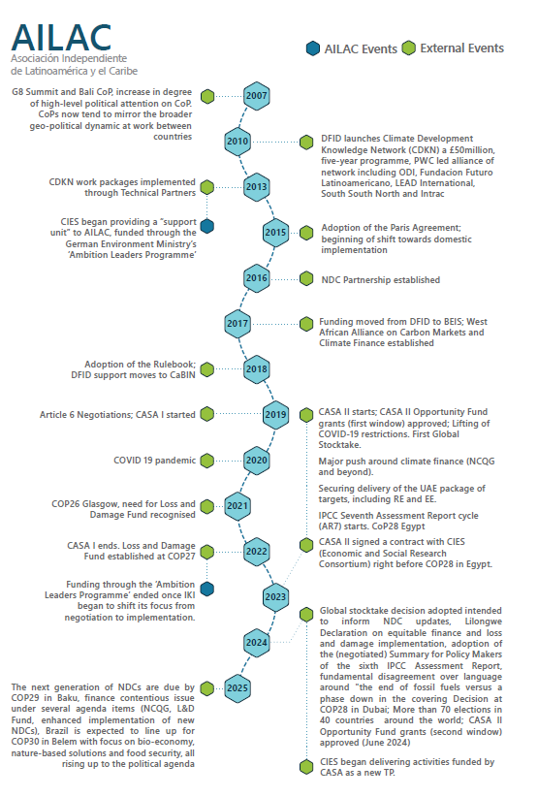
Figure 5. Timeline for the AILAC case study

Case study 5: Independent Alliance of Latin America and the Caribbean
Outcome title: Consorcio de Investigación Económica y Social (Economic and Social Research Consortium) (CIES) has enhanced and retained the capacity of negotiators, delegates, and institutions within certain AILAC countries and is helping them develop their own visions for the future to confront the impacts and risks of climate change. | Strength of evidence  Weak/Insufficient

Summary of CASA II contribution
Insufficient evidence to support a contribution judgement
CIES provided capacity building for junior/younger delegates from Costa Rica to build ‘permanent capacity’ at the Ministry of Environment. One directly supported negotiator from Costa Rica was reported to have taken a high-profile position on the UNFCCC Bureau through the support provided by CASA II. While the programme has strengthened individual capacity within Costa Rica and Panama, it is too early in the process to judge the contribution of CASA II to larger institutional outcomes (i.e. changes at the ministerial level).

Summary of the contribution of other actors and factors
- CIES has run an AILAC support unit since 2013. | Critical contribution
- Previously funded programmes, such as the Ambitious Leaders Programme, funded through Germany’s International Climate Initiative (IKI), and the current IKI-funded Learning by Doing Lab (LBDL), supported capacity building for many years prior to CASA II support. | Important contribution​
- Other multilateral agencies like UNDP and regional development banks, such as Corporación Andina de Fomento and IADB, have funded capacity development in AILAC countries. | Important contribution​

Geographic and temporal context
CIES joined CASA as a TP in early 2024 with the aim to integrate focus and support of the programme on domestic implementation and policy within the AILAC region. It has a longstanding relationship with Latin American and Caribbean countries and has provided ongoing support to South–South coalition building, with a particular focus on engaging middle income countries (MICs) in the AILAC informal negotiating group. The group is formed of Colombia, Costa Rica, Chile, Guatemala, Honduras, Panama, Paraguay, and Perú. The group was prominent in developing positions that eventually became part of the Paris Agreement, including influencing the goals on finance and adaptation. AILAC has pushed for transparency in mitigation by developing countries, going beyond the G77+China group’s emphasis on adaptation and Loss and Damage.
In regard to climate adaptation and mitigation, MICs find themselves in a challenging position. While LDCs are especially vulnerable to climate change and cannot afford to adapt or mitigate, MICs are economically better off but still have weak institutions with oftentimes limited administrative capacity and fragmented inter-ministerial coordination. Often, the size of the economy may not be a match for the mitigation or adaptation challenges facing the country. Since 2013, CIES has been staffing an AILAC ‘support unit’ with experts delivering advisory, local capacity, and coordination in UNFCCC negotiations to AILAC countries and national civil servants. CIES supports multilateralism through the building of a coalition of the willing to advance negotiations on Just Transition and Article 2.1​ (i.e. the Paris Agreement objectives, including finance).

What did the TP do?
CIES aims to balance negotiations and implementation by strengthening capacity in supported countries to act on the Paris Agreement, specifically Just Transition and Article 2.1. The goal is to enhance and retain the capacity of negotiators, delegates, and institutions within AILAC countries and help them develop their own visions for the future.
Pathway 1: Capacity and institutional strengthening. CIES delivered workshops to strengthen the capacities of lead negotiators from AILAC member countries (predominantly Costa Rica, Guatemala, Dominican Republic, Chile, Panama, and Peru) and other stakeholders (such as private sector actors and civil society leaders) engaged in UNFCCC negotiations through AILAC.
CIES utilises ‘elders’ in the delivery of support and was using this approach already prior to receiving CASA funding. Elders (former heads of delegation, an ex-minister, ambassadors, etc.) provide a highly experienced advisory support to delegates before, during, and after COPs and SBs.
Training has included pre-COP28 orientation and coordination in AILAC countries and real-time support and mentoring during COP28 in the UAE. This resulted in, among other outcomes, a revised AILAC Global Stock Take position and a text agreement before the close of SB60. In addition, the TP provides access to innovative tools and technologies, such as Notion, an online relational database, to give insight and resources to negotiators to use during negotiations. CIES also drafted memos on possible negotiation lines for intersessional meetings prior to COP28, including suggested lines to take on the NCQG and side meetings (Cartagena Dialogue), as well as draft submissions for submission to the UNFCCC.
In Costa Rica, CIES helped train a new Costa Rican negotiation team of around eight people, prior to COP28, and 15 people prior to COP29 and SB62. The project directly supported 10 delegates to attend COPs, SBs, and AILAC meetings.
The TP provided advance negotiation advice to the Head of Delegation (HoD), helped mobilise personnel to attend the COP, and provided in-situ negotiation and policy advice to the HoD and team at COP28 and COP29, the SBs, the Cartagena Dialogue, and AILAC coordination meetings.
CIES also facilitated and contributed to the coaching of the Costa Rican HoD and supported the Environment and Energy Minister to work as adaptation envoy for the COP29 presidency.
Finally, the TP delivered training to a group of Costa Rican youth and new negotiators. CIES also developed a process to exchange views with the elders.
Pathway 3: Support to implementation and review mechanisms.
Since January 2025, CIES has been supporting Panama in setting new priorities for its Ministry of Environment and supporting the drafting of climate change laws. At the ministry’s request, several initiatives have already been reviewed, including both climate change and other multilateral environmental initiatives, such as Biodiversity Beyond National Jurisdiction and Convention on Biological Diversity. Specific to climate change, CIES is supporting the review of reforestation and afforestation plans, as well as adaptation measures regarding the expansion of the Panama Canal watershed, which has been going through judicial and executive processes. Draft legislation is currently being reviewed internally, with CIES expected to provide a comparative review of legislation from the region.
The TP’s support to Costa Rica involves negotiations support in addition to implementation. CIES is currently supporting the country with climate change policies of relevance to the negotiations, specifically: supporting three different NDC enhancement working groups focused on energy, transport, and adaptation; supporting the drafting of policy proposals for Article 6 implementation; and support on proposals and activities for agro-forestry landscapes, to be used to inform both UNFCCC negotiations and domestic policy.
CIES has supported the development of Costa Rica's Third NDC, which is aligned with a new Costa Rican climate change law.⁸

Intermediate outcomes – What changed?
The training of civil society leaders (including youth), in addition to government delegates including by ‘elders’, expanded Costa Rica’s pool of possible negotiators ahead of COP29. Three of the trainees (the new HoD, a youth negotiator, and the Climate Change Ambassador) were selected to be on the Costa Rican Minister’s support team, which assisted the COP Presidency team in coordinating ministerial consultations on adaptation and, ultimately, helped draft the adaptation text which, however, could not be adopted at COP29 due to strongly divergent views across parties.

The three Costa Rican youth trained by CIES are now all part of Costa Rica’s delegation. One has been assigned to AILAC’s NCQG coordination, another to the adaptation coordination, and the third to the just transition team. According to CIES, these new negotiators are now capable of preparing an analysis of country submissions.

In Costa Rica, CIES supported the development process of the Nationally Determined Contribution (NDC) 2025–2035. The assigned CIES ‘elders’ advanced three NDC streams (modelling and decarbonisation plans, energy, and adaptation), coordinated one of them, and provided in situ policy support for development of the climate change law. The Third NDC and accompanying law are expected to be finalised before COP30.

Building on CIES training, Costa Rican civil society prepared project proposals to Germany’s IKI fund programme. Importantly, the Costa Rican government has now found other means to continue funding the negotiators trained by CIES ‘elders’.

Building on the success of the work in Costa Rica, CIES is now delivering support using a similar approach in Panama and Chile. The ‘elders’ are now replicating the scheme with incoming HoDs for the next administration. ​Panama’s Ministry of Environment has confirmed CIES’s support to domestic implementation through a letter of interest.

How effective were the TPs during the period?
The evaluation was unable to validate the intermediate outcome- and outcome-level changes reported by CIES due to non-responses from CIES-supported negotiators and delegates. Therefore, the effectiveness of CIES TA cannot be reported.

What were other advocates/actors doing during the same period?
Previously funded programmes, such as the Ambitious Leaders Programme, funded through Germany’s IKI, and the current IKI-funded LBDL, provided both a strong foundation on engagement and delivery of AILAC support, as well as continuity in the trust and reputation built over years. The LBDL is an IKI-funded initiative that brings together multidisciplinary teams from various countries to co-develop visions and practical strategies for climate-resilient societies. The project emphasises experiential learning and collaboration across civil society, academia, and government to address climate challenges and implement the Paris Agreement goals. The LBDL also provides resources to AILAC.

Other multilateral agencies provide support for implementation to countries that CIES works in. UNDP, for example, does not directly support negotiators but will fund secondments. Regional banks, such as Corporación Andina de Fomento, are supporting the deputy director of climate change in Panama to attend UNFCCC meetings.

What were the key factors in determining the outcome?
CIES has run an AILAC support unit since 2013 and is based in the Global South, which aids in the reach and relevance of their work. CASA II utilised the well-established trust-based relationships already present within AILAC. In addition, the outcomes were built off the success and work of previously funded programmes, such as the Ambitious Leaders Programme, funded through IKI, and the current IKI-funded LBDL, supported capacity building for many years prior to CASA II support. Finally, other multilateral agencies like UNDP and regional development banks, such as Corporación Andina de Fomento and IADB, have funded capacity development in AILAC countries.

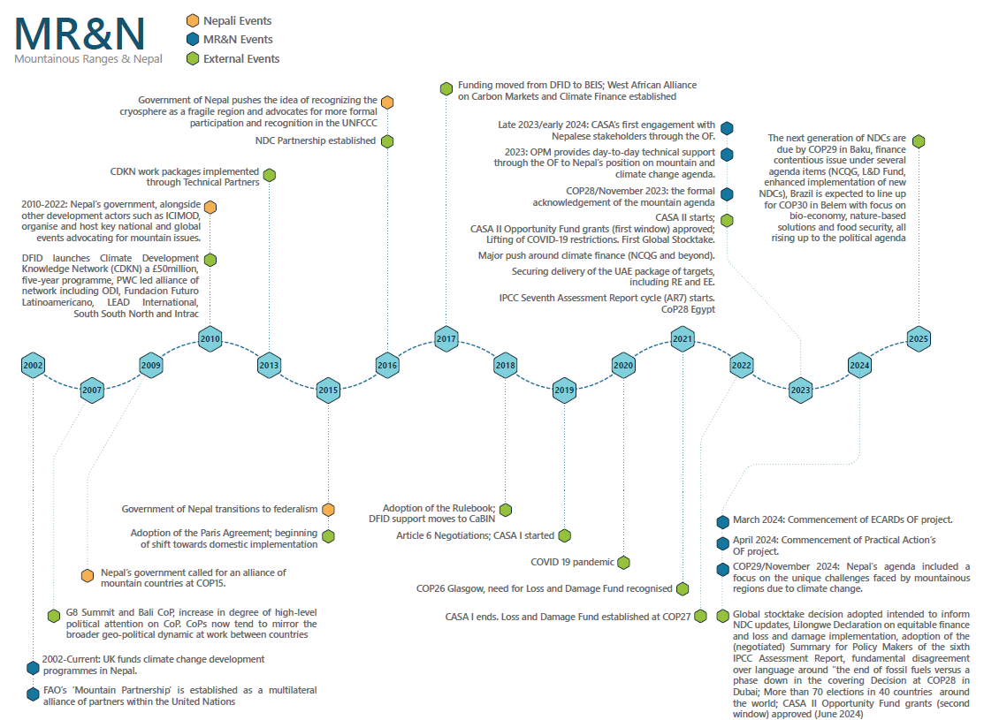
Figure 6. Timeline for the Mountainous Ranges and Nepal Case

Case study 6: Mountainous Ranges and Nepal
Outcome title: OF grantees in Nepal strengthened government and stakeholders’ influence and engagement in UNFCCC and further enabled the country to take transformative actions to confront climate change both domestically and abroad. | Strength of evidence  Strong

Summary of CASA II contribution
More confident than not that CASA II made some contribution
Nepali leadership has visibly committed to steering the global mountain agenda. It has also worked to tackle the climate crisis through a variety of national policy measures, including the Framework on Local Adaptation Plans of Action (2019) and the Disaster Risk Reduction National Strategic Plan of Action 2018–2030.
Providing technical expertise and capacity support is key to continuing momentum within Nepal: CASA funding (between late 2023 and May 2025) was cited as instrumental in allowing the OF grantees to continue providing their enabling and strengthening support to the government, who called for more capacity support to operationalise their climate change ambitions.​
Grantees trained negotiators (including younger delegates) and provided strategy and technical assistance, specifically for high-level dialogues on the Mountainous Ranges Agenda. All four grantees fostered an inclusive presence of diverse stakeholder voices, either by engaging them locally (development of Local Adaptation Plans of Action (LAPA)) and/or by enabling them to be present at UNFCCC through NDC 3.0 development consultations.

Summary of the contribution of other actors and factors
- Pre-existing long-term support to the Government of Nepal (GoN) by the UK Government in climate change and development. | Important contribution​
- Funding came at the right time, with strong demand from GoN for targeted support. | Important contribution​
- Several other (multilateral) stakeholders contribute to the Mountainous Ranges agenda setting and Nepal’s NDC development process | Important contribution

Geographic and temporal context
Nepal is an LDC at high climatic risk due to the country’s fragile topography, the climate-sensitive livelihoods of its people, and their limited adaptive capacity. The increasing frequency of climate change-induced events has led to the idea of seeking recognition of the cryosphere (e.g. those regions covered by ice or snow) as being particularly fragile. Mountainous countries, like other vulnerable countries, could organise and be recognised as such under the UNFCCC, as is the case with SIDS. However, unlike the SIDS, who have an established caucus, there is currently no coordination or representation of the unique interests of mountainous countries in the UNFCCC process. In this context, it is worth mentioning that Nepal, while currently a member of the LDC negotiating group, is scheduled to graduate from that group in 2026.
Nepal submitted its Second NDC to the UNFCCC in December 2020. It also prepared an Adaptation Communication, which includes its priorities, implementation and support needs, plans, and actions through a NAP. Nepal’s climate change experts noted that for adaptation strategies, a focus on locally led principles and boosting local capacities is key, along with a “nuanced and skilled negotiation team, well-versed in Nepal’s sectoral priorities.” However, despite Nepal’s policy to allocate significant adaptation resources at the local level, institutional mechanisms and capacities currently fall short. A Third NDC that better aligns Nepal’s ambitions and needs will be prepared ahead of COP30 in 2025.
Since before Copenhagen (2009), there has been recognition of the need for a negotiating group of mountainous countries. In Cancun in 2011, a proposal was floated to establish an Alliance of Development Mountainous States. This did not receive traction. All the involved countries, while having mountainous ranges, are spread across all continents and have very diverse socioeconomic profiles (e.g. the Andes, Himalayas, other Central Asian Mountain ranges and the Alps, etc.). At COP28 (2023), the Kyrgyz Republic proposed the creation of a permanent negotiating group called the Group of Mountain Partnership within the framework of the UNFCCC. This involved Tajikistan, Nepal, Bhutan, Andorra, Armenia, Zimbabwe, and representatives of the International Centre for Integrated Mountain Development (ICIMOD). The members of ICIMOD are Afghanistan, Bangladesh, Bhutan, China, India, Myanmar, Nepal, and Pakistan. The Kyrgyz Republic, Andorra, Bhutan, Nepal, and Bangladesh were among the countries that aligned themselves with this proposal. A COP decision was taken to conduct an expert dialogue.

What did the OF grantees do?
There are four OF grantees that delivered interventions supporting the GoN and other stakeholders from Nepal active in the UNFCCC across all major agenda items (mitigation, adaptation, and Loss and Damage): Oxford Policy Management (OPM), Practical Action, the Environment, Culture, Agriculture, Research and Development Society (ECARDS), and the Prakriti Resources Institute (PRI). Some of the grantee support overlaps. Both OPM and Practical Action, for example, were supporting Mountainous Ranges Agenda development at varying degrees and with different scopes. Likewise, both Practical Action and ECARDS provided facilitation services and other support to local government consultations, again albeit for different purposes. Practical Action and PRI delivered training in negotiations to different types of stakeholders. This intervention support is specified in the table below.
Theory of change causal pathway, e.g. mechanisms of change | OPM | Practical Action | ECARDS | PRI (subcontracted to IIED)
Capacity and institutional strengthening
Training of negotiators | Provides day-to-day support and strategic advice on Nepal’s position on the mountain and climate change agenda.  Trained junior/ youth negotiators in May 2024 on Loss and Damage. | Provided training to government on Loss and Damage; held mock negotiations ahead of COP29 to practice procedures.  Delivered the negotiation training for around 50 Nepalese participants who work to formalise the agenda. | Capacity building of government officials for climate adaptation negotiations. A total of 164 people were trained in climate change and LAPA processes. | Trained LDC junior negotiators (both those new to negotiations and youth) within the government nominated by their national focal points. Most come from Nepal, but they do train other LDC junior negotiators in the Asia Pacific region as well.
Access to and engagement in negotiations
Facilitation and support during negotiations | Requested by the GoN to support in the facilitation of an International Expert Dialogue on Mountains, People, and Climate Change in May 2024.  Established the Secretariat in the GoN for the Mountainous Ranges Agenda.  Hosted the first expert dialogue on Mountains and Climate Change at SB60, including representatives from all mountain countries' parties.  Supported a main event at COP29 with the GoN focused on the Mountainous Ranges Agenda and provided support for government officials to attend a series of side events related to their positions.  Key supporter of the GoN in helping it organise the Sagarmatha Sambaad Dialogue in May 2025. | Helped prepare the GoN ahead of COP29 by helping it prioritise key positions.  Provided in-situ support during COP29 to the GoN.  Held consultative workshops on NDCs to prepare the GoN team ahead of and at COP29.  One of the supporters to the GoN helping it organise the Sagarmatha Sambaad Dialogue in May 2025. | From the LAPA preparation, supported three GoN officials working on adaptation at COP29 in Baku.  Conducted consultations at each municipality where marginalised people shared their unique challenges. This information was provided to federal representatives, aiding climate negotiators in targeting support and resources for specific ward levels and groups. | Provided in-situ support to the junior negotiators at Bonn/SB60 and SB61.
Domestic implementation support
Support/  facilitation/ delivery of implementation mechanisms | Organised a series of dialogues and consultations with various groups of stakeholders, including youth and women from affected communities, to bring their voices and input into the Mountainous Ranges Agenda. | Highlighted the importance of adaptation plans and implementation for mountain communities and downstream linkages.  Worked with GoN stakeholders to finalise and submit the NDC 3.0 for COP30 in Belém. | Delivered GIS-based biophysical analysis, climate trends analysis, and a variety of training and consultative workshops within three municipalities to assist the GoN in preparing LAPAs using a Vulnerability Risk Assessment approach.

Intermediate outcomes – What changed?
ECARDS prepared three LAPAs that were endorsed by the respective municipalities with plans and activities to enhance the climate resilience capacity of vulnerable communities. LAPAs are community-driven plans that aim to help local governments and communities build resilience to the impacts of climate change. The LAPAs were presented at the federal level, and the information was used by Nepali negotiators at COP29 to bring the voices of communities to the negotiating table. This representation allowed for greater inclusion and equity of local groups and communities, who cannot attend negotiations in person. The LAPAs are now in the implementation phase with local governments, which have allocated some of their budgets to them, but will need to secure additional funding to implement the activities within municipalities.
Building on Practical Action’s training and capacity strengthening, Nepali negotiators were able to engage effectively and raise their voice at COP29 on Loss and Damage, finance, and the NDCs, where they advocated for a position that was informed by consultations undertaken in country prior to COP. CASA support enabled Nepal to enhance its NDCs to be aligned with country needs and ambitions on Loss and Damage and supported the GoN in submitting the draft version ahead of their release in April 2025. The inclusion of provisions on Loss and Damage is an area that only a few countries have addressed in their NDCs. Practical Action supported the integration of this component, highlighting the irreversible impacts of climate change, especially on high mountain ecosystems.
Practical Action was part of supporting greater Nepali government stakeholder engagement on NDCs. The NDCs provide the government with a bigger lever on the international stage. They detail where other countries can step in and provide the country with means of implementation, including climate finance and capacity support. At a post-COP29 meeting in Kathmandu, Practical Action presented the GoN with the outcomes and discussed its relevance to the draft Third NDC with the Prime Minister, Foreign Minister, and other high-level dignitaries. According to Practical Action, this type of engagement on NDCs had never happened before.
OPM strengthened the momentum and formulation of a dialogue by the GoN on Mountainous Ranges. CASA II’s OF, through OPM, supported the Nepali government to convene and bring together various stakeholders essential to the Mountainous Ranges Agenda through workshops and dialogues before, during, and after COP28, COP29, and SBB60. The GoN initiated and has now formalised the Sagarmatha Sambaad Dialogues, a biennial multi-stakeholder permanent global dialogue forum. The first ever Sambaad was held in Kathmandu on 16–18 May 2025 (after the postponement in 2020 due to the COVID-19 pandemic). Both OPM and Practical Action, through CASA OF funds, supported the GoN in the preparation of this first Dialogue. The government has allocated money to hold a Dialogue every two years. A lack of clarity as to the Mountainous Ranges Agenda remains and this first Dialogue received mixed reviews. Some commentators expressing concern about it being “yet another talk-shop” that missed the opportunity for Nepal to push strongly on key climate change issues. Despite this, a government stakeholder noted that events such as this were important for Nepal to help advance its position on climate change issues.

How effective were the TPs during the period?
Practical Action has been highly effective in facilitating and providing strategic input into Nepal’s Third NDC. This support was part of a much larger package of work delivered by Practical Action in Nepal for over a decade. For the Third NDC, the organisation facilitated cross-sectoral collaboration, including engagement with the relevant sectors, and supported the GoN’s climate policy processes. This proactive involvement fostered strong governmental buy-in and reinforced Practical Action’s credibility and influence on climate governance. Through effective training and capacity strengthening, Practical Action was able to support the GoN in synthesising already-recorded climate impacts and measurements and aligning them to their negotiating positions, setting them up for future reporting on climate change impacts.
A GoN official within the Ministry of Environment stated that Practical Action’s involvement was “very collaborative… We’ve had support from Practical Action and other actors for a long time, and they helped us formulate and prepare the documents for submission. This would not have been possible without Practical Action and the other organisations like Youth Alliance for the Environment.” In addition, the official noted that the expertise and members of Practical Action were:
“…very capable and experienced professionals who provide support as and when the government needs it. The support is very necessary for the government to participate in the UNFCCC process. It also helps the government at the community level with the adaptation work for the poor and vulnerable people. They help harness the voice of the local communities to ensure the government can bring these to UNFCCC.”
The official also remarked that the mock negotiations training Practical Action held before COP29 was very helpful and informed their UNFCCC strategy at COP29.
OPM acted as the key coordinator for the GoN involved in the Mountainous Ranges Group agenda setting at various junctions before, between, and after COP28 and COP29 and into 2025. Its facilitation and involvement was crucial as it filled key gaps in capacity within the GoN and allowed for greater depth and elevation of issues that otherwise would not have been present. Like Practical Action, OPM has a long history of working with Nepali stakeholders on climate change initiatives. The specific OPM team who received the grant was also the team that managed FCDO’s Policy and Innovation Facility programme from 2017 to 2023. They have well-established relationships with the GoN that allowed them to work very efficiently: as one OPM stakeholder reflected, “otherwise, government will not trust and engage in strategy on this piece of work. It really requires institutional memory and history of collaboration with the government.” An FCDO stakeholder also reflected that OPM served a “brokering role between the UK Government and the Government of Nepal, facilitating dialogue and collaboration to strengthen Nepal’s climate advocacy efforts.”
ECARDS worked highly effectively at the local, regional, and national levels in domestic implementation. The organisation works through three mechanisms to produce a finalised LAPA with the GoN: it establishes an Executive Committee to monitor field and data collection activities; it has a nominated focal person responsible for coordination and monitoring at the federal level within the Ministry of Forest and Environment; and each LAPA provisions for local area monitoring and reporting. According to representatives of ECARDS, they consulted and engaged nearly 800 community members in preparing the plans and sensitising them to climate change.

What were other advocates/actors doing during the same period?
Many other actors contributed to the observed outcomes. The GoN itself is a crucial actor in achieving this outcome: the OF projects all stand on the shoulders of Nepal’s leadership and the existing momentum already embedded within leadership and policies.
Mountainous Ranges Agenda setting. Other multilateral actors support GoN stakeholders in this agenda setting, including the FAO Mountain Partnership and ICIMOD. UNDP was also cited as being instrumental in supporting the agenda. There are bilateral and multilateral agencies that contribute as well, including FCDO, the EU, and the ADB.
Nepal’s political will to tackle climate change has been steadily increasing since 2009, when the country for the first time publicly voiced how it was facing an unavoidable crisis due to the changing climate.
Other actors who influence the Mountainous Ranges Group include the UN Secretary General and other countries involved in the Sagarmatha Sambaad Dialogue.
NDC development. The Ministry of Environment acknowledged the following other organisations as having supported NDC development: WWF, UNDP, UNICEF, UN Women, FAO, AEPC, Climate Analytics (a CASA TP), and the Youth Alliance for Environment.

What were the key factors in determining the outcome?
Pre-existing long-term support to the GoN by the UK Government over many years in climate change and development. This support laid the foundation for relationships and built trust with the Nepali government. OPM was uniquely positioned (given its experience and history in Nepal) to deliver (cost-) effective technical assistance, having acted as the manager of the climate change development programme Policy and Innovation Facility in the years 2017–2023.
Several other (multilateral) stakeholders contributed to the Mountainous Ranges Agenda setting and Nepal’s NDC development process. For the agenda, these include: the FAO, Karnali Integrated Rural Development & Research Center, UNDP Nepal, Mission East, and ICIMOD. Other countries within the Mountainous Ranges Group (i.e. the Kyrgyz Republic, Andorra, Bhutan, and Bangladesh) have also been important. Similarly, the NDC enhancement process was supported by multiple organisations alongside the CASA OF TPs, including: WWF, UNDP, UNICEF, UN Women, FAO, AEPC, Climate Analytics, and the Youth Alliance for Environment.
The OF grants are timely interventions that build on past success and relationships. The grantees (OPM Nepal, Practical Action, ECARDS, and PRI) have well-established climate change experts within the country (and internationally) that have built trust, reputations, and institutional memory with the GoN domestically and within UNFCCC negotiations. Previous UK-funded climate change development programmes allowed OPM to ‘springboard’ and further its support to the Ministry of Environment. Practical Action has worked with the ministry for several years. The OF projects also aligned with growing political ambitions and opportunities at the UNFCCC, where Nepal needed extra capacity and support.
Funding came at the right time, when there was strong demand from the GoN for targeted support. Other multilateral actors, such as ICIMOD, FAO and UNDP, contributed to a high degree to the Mountains Ranges Agenda setting and NAP/LAPA work alongside the grantees.

For example, the International Climate Initiative-funded IMPACT project (2016–2022) and the Gates Foundation’s US$ 200,000 grant to support LDC Group engagement at COP28 (2023).The Learning and Evaluation Partner team did not have access to further information relating to the proportion of budget that CASA represents for Climate Analytics.
Reportedly, the LDC Charter has been used as a benchmark by other negotiating groups such as the AGN and AILAC, who “sought informal advice to create similar documents” (Interview with Manjeet Dhakal, April 2025).
Further, LRI was invited to validation sessions for the Bill with other ministries, such as the Ministry of Finance, and stakeholder civil society, so LRI could hear their concerns and use that as a basis for recommendations. LRI’s role is also expected to extend beyond the Bill’s adoption, as it has been asked to support the development of delegated legislation to implement the framework. The process of incorporating feedback from the validation workshop into the draft is currently ongoing.
https://www.highambitioncoalition.org/statements/cp26-leaders-statement
https://casaclimate.org/news/our-fragile-planet-is-hanging-by-a-thread-guterres/
https://rmigov.com/?p=1927#:~:text=This%20updated%20NDC%20reaffirms%20RMI's,the%20impacts%20of%20climate%20change.
https://www.climatechangenews.com/2014/05/05/marshall-islands-primed-for-climate-fight-for-survival/
https://www.fijitimes.com.fj/marshall-islands-deliver-a-moral-call-to-arms-to-high-polluting-nations-greenpeace/#:~:text=%E2%80%9CThe%20Pacific%20nation%20is%20punching,Net%2C%20Kelvin%20Anthony%2C%20said .
https://islandsbusiness.com/news-break/punching-above-its-weight-pacific-pushes-for-ship-polluters-to-pay/
https://www.highambitioncoalition.org/statements/hac2023-leaders-meeting
https://www.climateforesight.eu/articles/we-will-not-go-silently-to-our-watery-graves-how-to-save-a-nation-from-drowning/
https://www.washingtonpost.com/politics/2023/11/29/seven-people-watch-cop28-climate-talks-dubai/
CIES’s 2024 amended workplan.
The Dominican Republic is not formally a member of AILAC but has been associated with AILAC positions.
Mountain Journey Nepal
Dr. Popular Gentle, “Ways forward for Nepal,” The Rising Nepal, 11 January 2024. Ways Forward For Nepal
Ibid.
https://centralasiaclimateportal.org/unfccc-cop28-kyrgyzstan-initiative-to-establish-a-negotiating-group-on-mountain-partnership-supported/
Prakriti Resources Institute received their grant as a sub-contractor to IIED due the Institute not being able to meet CASA’s compliance requirement of holding a foreign currency account.
https://mountain.mofe.gov.np/
Dhnagadimai Municipality of Siraha district 2. Gokulganga Rural Municipality of Ramechhap district 3. Barpak Sulikot Rural Municipality of Gorkha district (CASA2 Final Report, ECARDS Nepal, 2025, p. 3)
Himalayan meltdown | Nepali Times
Other support Practical Action has provided includes: formulation of Nepal’s NAP, Nepal’s Climate Policy 2019, NDC 2021, NAP 2021, and the Strategic Action Plan for Early Warning Systems 2022–2024. CASA funding was delivered for activities starting from 1 April 2024, which includes primarily the NDC development and support to the Mountainous Ranges Agenda setting.
Home | Mountain Partnership | Food and Agriculture Organization of the United Nations
Secretary-General's video message to the "Sagarmatha Sambaad" - Everest Dialogue | United Nations Secretary-General
(32) Post | LinkedIn

